
Creating Confident Leaders of Character!
Student Handbook
2770 Old Washington Rd Waldorf, MD 20601
301-645-1650
Fax: 301-645-1650
www.waldorfmartialarts.com
E-mail us at: waldorfmartialarts@gmail.com
Waldorf Martial Art’s Mission
Our mission is:
To provide our students with an exceptional Taekwondo program in a clean and friendly, family- oriented environment.
To always teach our students to the very best of our ability.
To guide our students to try their very best not only with their Taekwondo training, but in everything that they attempt.

Dear Student, Welcome to Waldorf Martial Arts!

Welcome to Waldorf Martial Arts (WMA). You have chosen the finest school in the area, dedicated to making your martial arts experience enjoyable and rewarding. Our team of instructors are the best. And they are dedicated to assisting you in being the best that you can be.
Our program is structured so that our students develop a wide variety of personal safety skills, including kicking, punching, and blocking. As our students learn these skills, they are also absorbing the social and mental benefits for which the martial arts are renowned: self-discipline, respect, courage, honesty, compassion, commitment, and self- sacrifice. At Waldorf Martial Arts, we not only teach our students to defend themselves we teach them to better themselves mentally, physically, and socially. Although we honor martial arts traditions that go back centuries, we are not static. We constantly seek new and innovative ways to enthuse and excite our students.
This handbook has been developed so that we may better serve you. It contains the information you will need to take advantage of the many programs we offer. Please keep it available for future reference.
Your best interests are always uppermost in our minds. Our instructors and staff are always ready to help you in any way during your training. We will be happy to discuss your progress at any time.
Best wishes on the journey you have now begun.

Sincerely,
The Waldorf Martial Arts Staff

Table of Contents

About the Academy… 5
Philosophy 5
WMA’s Founders… 5
What is Taekwondo?. 7
A Brief History… 7
The Purpose of Taekwondo 8
School Communication 8
WMA Website and Facebook Fan Page. 8
WMA Monthly Calendar 8
Announcement Boards. 9
Class Announcements… 9
Suggestions & Comments… 9
Private Appointments… 9
School Procedures and Policies… 9
Student Attendance… 9
Class Schedule… 9
Class Dress Code… 10
School Closing… 10
Lost and Found 10
Take Pride in your school! 10
Guest Policy… 10
Smoking Policy… 10
Pet Policy… 10
Tuition and Your Agreement 10
Required Safety Rules of our School… 11
Disciplinary Procedures…………………………………...11
Required Safety Gear… 13
Classroom Sparring Rules… 13
Additional Student Services and Programs…………...14
The Pro Shop…………………………………..…..…….14
Special Help Classes………………………….……….14
Buddy Days…………………………………………….....14
VIP Sponsorship Guest Pass &Prize Wheel…14
Academic Achiever………………………………….…14
Tournaments and Clinics………………………………14

Curriculum and Advancement 15
What We Teach 15
How we teach 16
Lil’ Dragons… 16
Junior’s Program… 16
Teen & Adult Program… 16
Class Structure 16
"A" days 16
“B" days 16
Our Belt-Promotion System… 17
Progress & Promotions… 17
The “Stripe Test”… 17
The “Belt Test”… 17
Required Curriculum by belt rank 19
White-Orange Belt Curriculum… 19
Yellow-Blue/Purple Belt Curriculum…………20
Purple Belt-Red/Black Belt 21
Black Belt Curriculum……………………………..22
Five Tenets of Taekwondo… 23
The Taekwondo Oath… 23
Korean terminology… 23
How to tie the Uniform Belt… 24
Explanation of Shoulder’s Distance as a measure for stance length and width…………………………25
Chamber Positions for Basic Techniques………27
Forms: Ki Cho to Chung Moo. 33
10-Count Drills……………………………………………..49
Step Sparring 49
Ho Sin Sul ( Adv. Self-Defense) 55

About The Academy
Waldorf Martial Arts was established in 1987 in an effort to offer the Waldorf Community a quality family environment in which to practice the martial art of Taekwondo. Our focus today remains the same as in the beginning: to provide a quality environment where families grow strong together through the discipline of martial arts practice.

Philosophy
Waldorf Martial Arts approaches instruction in Taekwondo as not merely a method of learning how to defend oneself but rather as a way of living one's life and developing one's character. Put simply, academy members strive to become better people, both physically and mentally. They do this by not only practicing the Art's physical techniques, but also by structuring their lives by a set of tenets (Code of Ethics). There are five tenets:

COURTESY: Refers to the student’s ability to respect themselves, as well as others.

INTEGRITY: Refers to the student’s adherence to an honor code of behavior. This concept entails striving to be honest with oneself and others in both thought and action. This approach enables students to develop their strengths and minimize their weaknesses.

PERSEVERANCE: Refers to the student holding steadfast to a course of action, belief, or purpose. This tenet governs the student's tenacity, or ability to complete what is begun.

SELF-CONTROL: Refers to the student's capability to keep their emotions consistent and in balance over time. Developing this principle will permit the student to better live in harmony with self and the environment.

INDOMITABLE SPIRIT: Refers to the student’s freeing their spirits in a manner that enables them to achieve the greatest level of potential. This ideal also encourages students to tirelessly pursue and stand firmly for the principles they hold to be true. This tenet governs the student's self-confidence.


WMA’s Founders

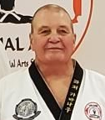
(John) Roger Cavanaugh – AKA: Mr. C.
Master Cavanaugh began his training in January 1977. His training spans many different martial arts styles including Chungdokwan Taekwondo, Tang Soo Do Moo Duk Kwan, Shaolin Long Fist Kung Fu, Yang-Style Tai Chi, Pa Qua, Hsing Yi, Escrima, Shorin Ryu Karate, Jui Jitsu, Japanese and Okinawan Weapons, Ninjitsu, Pierce Family Bladed Weapons training, and Western Boxing.

He holds an 8th Degree Black Belt in Taekwon-Do, 1st Degree Midnight Blue Belt in Tang Soo Do, Black Sash Sifu Certification in Shaolin Long fist Kung Fu.
Promotions:
- 1st Degree Black Belt, Taekwon-Do, 1979, GM In Mook Kim, ACTA.
- 1st Degree Midnight Blue Belt, 1981, GM Myung Sook Seo, US Tang Soo Do Moo Duk Kwan Association.
- Black Sash Shaolin Long fist Kung Fu, 1986, Sifu Michael J. Barry.
- 2nd Degree Black Belt, Taekwon-Do,1989, GM In Mook Kim, ACTA.
- 3rd Degree Black Belt, Taekwon-Do, 1991, GM In Mook Kim, ACTA.
- 4th Degree Black Belt, Taekwon-Do, 1994, GM Les Zampino, AAU Taekwondo.
- 5th Degree Black Belt, Taekwon-Do, 1998, GM Les Zampino, AAU Taekwondo .
- 6th Degree Black Belt, Taekwon-Do, 2004, GM Les Zampino, Northeast Taekwon-Do Association.
- 7th Degree Black Belt, Taekwon-Do 2011, GM Les Zampino, Northeast Taekwon-Do Association.
- 8th Degree Black Belt, Taekwon-Do, 2019, GM Les Zampino, Northeast Taekwon-Do Association.

Bachelor’s Degree, cum laud, University of Louisville, 1978. 4.0 in master’s course work (ABT).

Former Taekwondo, Tang Soo Do, and Open Tournament Champion

Past Positions include:
- Maryland AAU Association Vice President
- Taekwondo Chairman for Maryland AAU Association
- AAU Taekwondo Regional Director
- AAU Taekwondo National Executive Committee member
- AAU Taekwondo National Convention Committee Delegate
- AAU Taekwondo AA-Level National Referee/Official

Recognitions:
- Recipient of the AAU Taekwondo “David Rivenes” award 1996.
- Recipient of the AAU President’s National Leadership Award for outstanding service 1997
- Recipient of the International Martial Arts Association Martial Arts School of the Year award for 1997
- Recipient of the Maryland AAU outstanding Volunteer of the Year for 1998

Master Cavanaugh (a.k.a.: “Mr. C.”) began his Martial Arts Training in January 1977, at the University of Louisville. The American Chung Do Kwan Taekwondo Association (ACTA) began a university club that and Master Cavanaugh was a charter member. Master Cavanaugh received his Black Belt in August 1979, from Grand Master In Mook Kim, founder of the ACTA. Shortly thereafter, he moved to the Washington, D.C., area.

Upon relocation, Master Cavanaugh, not finding a Taekwondo school in his neighborhood, began studying another Korean Martial Art call Tang Soo Do and, in 1982, received his Midnight Blue Belt (the equivalent of a Black Belt in Taekwondo) from The United States Tang Soo Do Moo Duk Kwan Federation; U.S. affiliate to the Korean Soo Bahk Do Association, Grand Master Hwang Ki.

Master Cavanaugh also had the opportunity to study the Chinese Art of Shaolin Long Fist Kung Fu and received a Black Sash in 1986 from Si-Gung Michael Barry. He also was certified in Yang Style Tai Chi Chuan in that same year.

In 1987, Master Cavanaugh decided to continue his training in Taekwondo directly under Grand Master In Mook Kim as well as begin teaching. Along with his wife, Master Debbie Cavanaugh, he established the Waldorf Taekwondo Academy. Today, the academy’s name is Waldorf Martial Arts.

Master Cavanaugh has trained with many legends in the martial arts… Jason David Frank, the original Red Power Ranger, Bill “Superfoot” Wallace, undefeated middle weight PKA kickboxing champion, Joe Lewis the PKA heavy weight undefeated champ. Ernie Reyes Sr., choreographer of ninja turtles and film star, Stephen K. Hayes, brought ninjitsu to America, Grandmaster Jhoon Rhee, founder of American Taekwondo, Herb Perez, 1992 Olympic Gold medalist, Lynette Love, 1st USA Gold medalist in the 1988 Olympics, Sifu Dennis Brown, a legend in Chinese Kung Fu, Grandmaster Park, a Hwa Rang Do expert, Korean sword expert, and world renown artist.

During the 1970 & 1980’s, Master Cavanaugh competed in numerous Taekwon-Do, Tang Soo Do and open championships securing gold, silver, and bronze medals in forms, sparring, and team sparring events. Using his past competition experiences, he has also coached many of his students to win at the local regional, national, Junior Olympic, and world championship levels.

Click this link to watch a video of Mr C. in action during his competitive years!

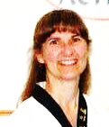
Deborah J. Cavanaugh – AKA: Ms. C.
8th Degree Black Belt in Taekwon-Do, 1st Degree Midnight Blue Belt in Tang Soo Do, Black Sash Sifu Certification in Shaolin Long fist Kung Fu.

Graduate of Prince Georges College

49 years’ experience in Taekwondo, Tang Soo Do, Shaolin Long Fist Kung Fu, Tai Chi Chuan & Shuto Kahn Karate

Former Taekwondo, Tang Soo Do, and Open Tournament Champion

Past Positions include:
- AAU Taekwondo Regional Secretary-Treasurer.
- AAU Taekwondo National Convention Committee Delegate

Recognitions:
- Recipient of the International Martial Arts Association Martial Arts School of the Year award for 1997
Master Cavanaugh (a.k.a.: “Mrs. C.”) began her Martial Arts training in July 1974 at Prince Georges Community College, Largo, Maryland. The style was Okinawan Shuto Kahn Karate. Master Cavanaugh also received instruction in Hap Ki Do and Ju Jit Su while studying Shuto Kahn.

In 1981, Master Cavanaugh began study in Tang Soo Do, Moo Duk Kwan, and, in 1984, received her Black Belt from the United States Tang Soo Do, Moo Duk Kwan Federation, Grand Master Hwang Ki, founder of Tang Soo Do. It was during this time that Mr. and Mrs. Cavanaugh met and were married.

In 1984, Master Cavanaugh, along with her husband, began study in Shaolin Long Fist Kung Fu and Tai Chi Chuan. Master Cavanaugh resumed her training in Taekwondo in 1987 at the Cavanaugh’s newly formed Club.

Today, Master Cavanaugh continues teaching Taekwondo at Waldorf Martial Arts along with her husband and daughter.

A Brief History

What is Taekwondo

Taekwondo is a Korean Martial Art. “Tae” means foot, “Kwon” means hand, and “Do” (pronounced “doe”) means “the Way”. Literally translated it means The Way of the Foot and Hand. The word “Taekwondo” was coined in 1955 by a South Korean Brigadier General named Hong Hi Choi. Taekwondo was born out of an indigenous Korean Foot-Fighting art called Tae Kyeon and Japanese Karate (which the General learned while imprisoned by the Japanese Government during their occupation of Korea). General Choi headed up the Military School of Taekwondo called the Oh Do Kwan (meaning School of My Way). The Famous South Korean 29th Infantry Division (also known as the White Horse Brigade) was the vehicle through which he developed Oh Do Kwan Taekwondo Training for the R.O.K. Armed Forces. At the same time a colleague of his, Won Kuk Lee, was training civilians in South Korea at the Chung Do Kwan School of Taekwondo (Chung Do Kwan means School of the Blue Wave). Master Lee’s Chung Do Kwan was the largest and most popular civilian Taekwondo School in Korea.

In the late 1950's and early 1960's, American Armed Forces were called to South Korea to help control the attempt of Communist North Korea to dominate the Democratic Republic of South Korea. While stationed in South Korea, many U.S. GI’s learned Taekwondo from the South Korean soldiers. Upon returning to the States, they began teaching Taekwondo themselves to Americans. Most notably, Chuck Norris, actor and martial artist, came back and began teaching Taekwondo to movie stars and film directors in Hollywood, California. This eventually led him to his now highly successful career in acting.

Today, Taekwondo is taught in countries all over the world. It is the most popular and most widely practiced of the Asian Martial Arts. In 1988 it was made an Olympic Sport Medal Sport.

Taekwondo is recognized, today, as not only the most effective and scientific method of learning self-defense but also as a fun and exciting means to teach our youth values such as respect, discipline, patience, courage, and effort. Adults practicing Taekwondo can expect reduced stress levels in their lives, keep fit and feel better, increase their energy and self-esteem, and enjoy the comradery and friendship of other adults with an interest in Taekwondo.

The Purpose of Taekwondo
Taekwondo is not a sport. While it does have a competition aspect, this is just one small facet of the Art. Furthermore, the competition aspect of Taekwondo was not developed to win medals at all, but rather to test one’s skills in a situation that, as closely as possible, resembles an actual self-defense scenario; it was meant to make a student face his or her own fears and learn to control them under pressure.

In reality, the Art of Taekwondo in its entirety is a way of thinking and acting. It is a way of life that all students can enjoy. The utmost purpose of Taekwondo is to develop an individual’s self-confidence and self-esteem; to help him or her realize their full human potential, not just physically, but mentally and spiritually as well! It challenges each individual to develop, to the fullest, their personal abilities.

In short, Taekwondo’s purpose is to strengthen the individual physically and spiritually through its rigorous training methods and morally and ethically through its philosophy. As Taekwondo accomplishes this end, we will begin to see stronger families which lead to stronger communities and ultimately to a more peaceful world for us all. This is the promise of Taekwondo, the Art. And everyone, young or old, male or female, weak or strong, big or small, may enjoy the benefits attained from practicing Taekwondo’s physical and philosophical lessons.

School Communication

WMA Website and Facebook Fan Page
Keep abreast of Events, activities, announcements, interesting articles, pictures, videos and more at www.waldorfmartialarts.com and on Facebook at https://www.facebook.com/waldorfmartialarts/

WMA Private Facebook Page
Keep abreast of important announcements and content not shared on our public Facebook Page by requesting to join the Waldorf Martial Arts student bulletin board at: https://www.facebook.com/groups/252167766178995

WMA Monthly Calendar
Every month, WMA publishes a Calendar of Events to keeps students and parents informed about upcoming events and activities. Please check your calendar each month and mark the important dates on your calendar. (also available on our website at: http://waldorfmartialarts.com/category/waldorf-martial-arts-students-monthly-calendar-of-events/

Announcement Board and Class Announcements
Our Announcement Board is located in the school’s lobby. Upcoming events are always announced during class as well. Please be sure to check the announcement board regularly for upcoming events, schedule changes, special classes, class cancellations, etc. There is also a monthly event calendar located at the school counter.

Suggestions & Comments
We are always open to suggestions and constructive comments about how we might be able to improve our school. Please write or type any suggestions or comments you have and drop them off that the school counter. Please don’t forget to put your name on any suggestion you submit so we may discuss it with you further.

Private Appointments
Appointments are always available during the day and evenings. Please call to schedule one if there is a need to discuss an issue or concern.

School procedures and Policies

Student Attendance

Attendance is crucial to progress. Progress keeps interest high. When interest is high, the goal is achieved. For this reason, attendance is closely monitored at our school. To help us do this, every student is issued an attendance card when they begin. Attendance cards are color coded based on the students Belt Color. Your instructor or an assistant will collect the attendance cards at the beginning of your class.

When you arrive for your first group lesson, ask our receptionist for your attendance card. Tell him/her that this is your first group lesson. He/She will prepare and give you your attendance card (and your uniform if you have not yet received it) and show you to your class.

After your first group lesson, you will be responsible for bringing your attendance card into class. If you have any problems finding your card, ask any of our staff and they will be glad to help.

Remember, your attendance card, in addition to being your record of attendance, is a visible indication of your progress toward your next stripe or belt. Please don’t forget to pick up your card and take it into class. It is to your benefit. Each belt rank has a minimum attendance requirement of two classes per week for advancement. We understand that sometimes missing class is unavoidable. If you know in advance that you are going to be absent, please call the school and let us know. It is the student’s responsibility to make up the class or risk being held back at belt promotion time.

If you are going on vacation, please be sure to let us know. If classes are being missed due to other sports activities, we recommend that you try to continue with your Taekwondo training with at least one class per week to maintain your skills. If this is not possible, please let us know so we can inform your instructors and put your program on hold if necessary.

Class Schedule
WMA offers an open schedule. You are not locked into specific days but may attend class at any regularly scheduled class for your rank and age. For beginner and intermediate ranks (white through blue/purple belts), a minimum of two classes per week is recommended. One class per week should be a designated "A" day, during which emphasis will be placed on Forms, One-step Sparring and Basic Technique Development. The second class-day during the week should be a "B" day, during which Free-sparring techniques & Self-defense skills are emphasized.

A copy of the current schedule, showing designated A and B days, is always available at the school counter. We will be glad to help you determine which days and times are best suited to your schedule. If you foresee a potential schedule conflict, please contact the school so we can help you solve it.

Class Dress Code
The basic Taekwondo uniform consists of white pants and a V-neck or Crossover top. Female students should wear a white T-shirt under the top. Students may also wear an approved rank T-shirt (available in our Pro Shop) with uniform pants. Black Belts may wear all black uniforms.

Students practice bare-footed, so shoes and socks should be removed before class (Special Taekwondo practice shoes can be worn for students who may need to wear shoes. They may be ordered at our school Pro-Shop).

School Closing
Closings for holidays or special events will be posted on the school message board in the viewing area and will be announced on the monthly calendar. During the winter, WMA does not follow the Charles County Schools closings for bad weather. If bad weather occurs, please call the school for pre-recorded closing information.

Lost and Found
All items that are left behind at the Academy will be stored in the Lost and Found. Small articles, such as jewelry, keys, and watches will be kept safely in the front office. All items that remain unclaimed for more than 30 days will be donated to the Charles County Children's Aid. Socks, mouthpieces, and supporters will not be kept. WMA is not responsible for articles lost or stolen at the academy.

Take Pride in your school. Keep it Clean!
We ask that each student and family take pride in your school by helping to keep it clean and trash free. If you see some trash lying around either inside or outside, please pick it up and dispose of it properly. Please report spills, messes, and bathroom accidents to a staff member so we can clean it up. If soap, paper towels, or toilet paper is needed in a bathroom, please let one of the staff know about it. A clean and trash-free school is a school we can all be proud of!

Guest Policy
Your WMA family is always delighted to meet your friends and relatives. If you would like to bring guests, please do so. We will be happy to accommodate them. Please don’t forget to introduce your guest to our staff and instructors. The school also provides special Buddy Day programs upon occasion. (See the section on Additional Programs.) Friends are always welcome at any of our extra-curricular events, too! Our VIP Trial Lesson Guest Passes are available at the counter if your guest is interested in taking lessons.

No Smoking Policy
Waldorf Martial Arts is a smoke free zone. However, patrons who wish to smoke may do so outside.

Pet Policy
Sorry, pets are not allowed inside of our school.

Tuition and Your Agreement
It is important to keep your tuition payments up to date. If there are ever any challenges to making timely tuition payments, please contact the academy about the situation.

Required Safety Rules of our School
Safety in the school is of vital importance. We must all work together to create a safe environment. If you observe anyone, at any time, who is failing, in your opinion, to maintain the highest levels of safety, report it to a staff member immediately. To maintain safety in our classroom and to maintain a positive and respectful Martial Arts environment, we request that our students follow these guidelines:

- Always place your shoes and socks neatly in the cubbies provided or under the benches so that they are out of the way.
- Respect the property of other people.
- Keep uniforms neat and clean.
- Practice good personal hygiene habits.
- Remove jewelry and wristwatches before entering class (with the exception of wedding rings).
- Respect the class that is in session: Lower the volume of your conversation, and quietly prepare for your class.
- Please be on time for your class. Arrive 5-10 minutes prior to your class.
- Always have your attendance card before entering class.
- Perform a formal "bow" before you step onto the mat.
- Always be well mannered and courteous toward others.
- Introduce your guests or visitors to an instructor.
- No unattended or unsupervised children are permitted on the training floor.
- Enter class with energy and demonstrate your enthusiasm for learning.
- Focus your eyes on your instructor.
- Always show your best attention and give your instructor proper responses to questions. That is, answer with "Yes Sir!" or "No Sir!"; "Yes Ma'am!" or "No Ma'am"!
- Always demonstrate proper posture and attitude
- No vulgarity or obscene language is permitted in the school.
- No gum chewing is allowed in class.
- Steady and consistent attendance is essential to progress. Please notify your instructor if you will be missing class.
- Memorize the Taekwondo Oath and recite it at the end of each class. Learning, Understanding, and applying its meaning will enhance your progress.
- Learn to tie your uniform and belt properly.

Disciplinary Procedures
Waldorf Martial Arts makes every attempt to follow a disciplinary procedure focused on the philosophy of “praise in public, correct in private”. However, if the behavior is dangerous to another student or results in disruption of the class structure, it will be dealt with immediately, even if during class. This is not with the intent to embarrass the student, but to restore safety and structure to the class. We ask our parents to understand that Martial Arts cannot be taught in an unstructured environment.

Minor Infractions
Removal of Stripe: These are mild to moderate behavior problems. General rule is one stripe removed per infraction; however, multiple stripes can be taken for multiple offenses or blatant disregard for student’s safety. Stripes can be earned back at the sole discretion of the instructor or staff member dependent upon corrected behavior. Examples of improper behavior include:

1. Disrupting class
2. Distracting another student during class by physical contact or by verbal distraction
3. Refusing to participate in class
4. Lethargically participating in class (not trying hard enough, well below ability)
5. Not standing or sitting in “Black Belt listening position” when told to do so by instructor or staff member
6. Use of equipment without permission such as climbing on wave-masters, throwing pads, etc.
7. Defacing or destroying school property
8. Running about the lobby while classes are in session
9. Not responding to verbal directions of instructors or staff
10. Not showing respect by responding “Yes sir/ma’am” to instructor or staff member
11. Shouting
12. Inappropriate touching
13. Not having uniform or having incomplete uniform
14. Goofing around in bathrooms

Major Infractions
Loss of Belt or Loss of Rank: Some examples of major infractions are:
- Destructive behavior
- Physical contact such as punching, kicking, pushing down or otherwise causing bodily harm to another student
- Physical damage to school property
- Running in the school after several warnings
- Using profanity

Major infractions can result in the loss of belt temporarily. If rank is taken, the student must retest to earn rank again.
Loss of Belt:
A student’s belt may be taken by instructor or staff for any major offense or repeatedly not following the directions of an instructor or staff member. There is no demotion in rank, but the students testing schedule changes as they cannot take part in a “stripe” or “Belt” testing without their belt. Based on the severity of the offense, the instructor may opt to do any of the following:

1. Set timeline for corrective behavior and when to return belt to student
2. Set indefinite period of time to watch for long term corrected behavior based on what the instructor/staff member needs to see corrected.
3. Give belt to parents and let them decide when to return it to student.
4. Give belt to another instructor or chief instructor and let them make final decision
While a student’s belt is on probation, they cannot take part in “stripe” testing, nor can they Belt test. They will miss their normally scheduled testing date and will not be eligible to test until their behavior has been satisfactorily addressed and corrected. They will be required to continue to take class, just line up in the back of the class as anyone who doesn’t have their belt would do.
Rank Removal (Demotion)
Reserved for serious offenses such as blatant disregard for other students’ safety, extreme disrespect to an instructor or staff member and/or the result of non-modified behavior after multiple warnings. The amount of demotion will be determined by the Chief Instructor. As a general rule, most students go down one degree in rank. However, it is possible to be demoted all the way back to white belt. Students will be required to retest to earn the next rank up from the adjusted belt rank. Testing date for this student will be determined by the Chief Instructors.
Our goal for all of our students is for them to have a Black Belt Attitude. We are not here to entertain, but to train all those who walk through our doors to become great Black Belts! A great Black Belt has an attitude of respect, determination, courtesy, perseverance, self-control and integrity! They also have indomitable spirit (an unwillingness to give up and the drive to be the best)!

FREE SPARRING

Required Safety Gear
Free-sparring is one part of the class curriculum that begins to be stressed more heavily at the Green Belt level; after the student has had nine to twelve months of training in various types of drills designed to prepare him/her for sparring. In order to fully participate in Green Belt classes, students should purchase protective sparring gear by the time they reach this rank.

Required gear for free-sparring includes foam dipped head gear, hand and feet gear, a mouthpiece and protective groin cup for males. Optional equipment includes shin pads, forearm pads, and rib protector (or full chest and stomach protector).

Sparring gear is available at our pro-shop in specially priced packages. Please be sure to personalize your safety equipment by printing your name with a permanent marker on each piece.

Classroom Sparring Rules
Equipment: All students participating in free sparring are required to wear approved protective gear.

Contact Free Sparring rules : Most Free-sparring sessions are conducted with students wearing protective sparring gear. Students, in such sessions learn strategies to maneuver and score “points” on their partner by making light contact to appropriate target areas with proper and appropriate techniques. Every precaution is taken during contact free-sparring practice to ensure the safety of the student. Indeed, very few injuries ever occur during free-sparring practice at our school.

- All punches and kicks are allowed to touch the target areas.

- Target areas with the hands include the stomach, chest, side of chest/stomach area above the belt, and head area covered by head gear. Hand techniques are not allowed below the belt, to the back, or kidney areas. Hand techniques are not allowed to the face or neck Light contact is permitted only to the areas of the head covered by head gear.

- Hand techniques that are acceptable during contact free sparring include punches, back fists, and ridge hand strikes. Hand techniques that are not acceptable during contact free sparring include any blind or uncontrolled hand techniques, as well as the following specific techniques: knife hands, spear hands, thrusting fingertip strikes, hammer fists and elbow techniques.

- Target areas with the feet include the stomach, chest, side of chest/stomach area and head area that is covered by head gear. Foot techniques are not allowed below the belt, or to the back, kidney, or neck areas.

- Foot techniques that are acceptable include any kick with the exception of blind techniques, sweeps, take-downs, or knee techniques.

Additional Student Services and Programs
Waldorf Martial Arts offers a wide variety of student services and programs in addition to regular classes to enrich the experience of our students and their friends.

School Office & Supply Store
WMA sells a variety of martial arts equipment, gear, apparel, and more. Catalogs are available free of charge for you to browse. Required sparring gear may be purchased one piece at a time, or you may choose to purchase a specially priced gear package. In addition, clothing items, such as T-shirts, jackets, pants, shorts, novelty items, and special training packages are available that bring you special savings on items martial artists want most.

Many items are in-stock, but special orders may be placed. These orders are placed the first and third week of each month and can take 1 to 2 weeks to be delivered. Gift Certificates also are available at the Pro Shop. The Pro Shop accepts cash, checks, American Express, VISA or MasterCard.

Special Help Classes
From time to time, a student may need special attention. When this is the case, a special help class may be scheduled. This class is a private session with an that focuses on trouble areas in the curriculum. To set up a special help class, permission must be obtained from one of the instructors.

Buddy Days
Special days will be designated as "Buddy Days," meaning that regular WMA students may bring a buddy to class, free of charge. Buddy Days will be announced on the monthly calendar.


VIP Sponsorship Guest Pass Program and Prize Wheel
The VIP Sponsorship Program allows you to bring your friends and relatives to our school to try out classes at no expense or risk. We recognize that it is more fun to train with a friend and that students who have friends to support them at class time will train longer and classes will be more enjoyable. You may pick up a VIP Gift Certificate at the Pro Shop counter. The Prize Wheel is located on the lobby counter. When a student refers someone to our school, they get to spin the prize wheel. The student wins whatever amount it lands on $$$!

Academic Achiever
Prize Wheel
This program is designed for our school aged children. Its purpose is to recognize Taekwondo students who also excel in their academic schoolwork. In order to qualify for this award, students must have regular attendance and receive nothing lower than an "A" or "B" on their report card. The award for this program is an “Academic Achiever” patch which is to be worn on the student’s TKD uniform top. Subsequent recognition of academic excellence is awarded by presenting “Academic stars” to be worn underneath the “academic Achiever” patch (red stars are awarded for all "A" and "B" marks on the report card; gold stars for straight "A" marks.)

Tournaments and Clinics
Tournament competition is not a requirement at WMA. Nevertheless, we do participate in tournament competitions, if you or your children would like to get involved. Tournaments are designed for all ages and ranks. Most tournaments consist of forms competition and sparring competition.

Curriculum and Advancement

What We Teach
Every movement in Taekwondo is scientifically designed with a specific purpose. Constant repetition teaches patience and how to overcome any difficulty. The tremendous power generated from one's body develops self-confidence. Sparring teaches humility, courage, alertness, accuracy, and self-control. Practicing forms teach flexibility, grace, balance, and coordination, while the basic class drills and exercises develop preciseness and teach the method, principle, and purpose. Eventually, Taekwondo training permeates every conscious and subconscious action of the student. Thus, Taekwondo offers a strict self-imposed discipline along with the spirit of cooperation and mutual respect.

Taekwondo also teaches tenacity and concentration, and it is also an effective form of relieving tensions and pressures from long hours of work and study. A session of training can refresh the student and help calm and clear the mind, permitting the student to focus their energy once again on the task at hand.

At each level of study (beginner, intermediate, and advanced belt levels), the WMA curriculum includes these basic components: Basic blocking, striking and kicking techniques; Predetermined choreographed sets of blocking, striking and kicking techniques called “forms”; block and counter maneuvers called “One-step Sparring”; and “Free-sparring.”

Forms can be compared to the floor exercises of gymnastics. Proper execution of one or two forms per rank is required for advancement.

One-step sparring drills are intended to help students perfect their blocking and evading skills, as well as their reactions. One-steps also focus on proper distancing, target acquisition, and reaction speed. At each rank, students are taught several new one-steps techniques. There are 44 in total.

Free-Sparring practice brings together all the different techniques and drills learned during class and combines them with the competitive spirit of a sport. Initially, class sparring includes no contact exercises; later, for more experienced students, contact drills and matches are included in the curriculum. Safety gear is required for any contact drills or Free-sparring matches.

Beginning at the intermediate ranks (green belt and above), board breaking is included in the curriculum. Board breaking teaches the student focus. It also develops proper distancing in addition to the proper execution of a technique. It also helps to develop the student’s self-confidence by eventually overcoming the fear of breaking the board. We have special “board breaking practice” nights each month. Please check the Monthly Calendar of Events to find out which night best fits your schedule. Ask your instructor to help you determine what size board you should be practicing with. Boards are supplied on board breaking nights free of charge.

How we teach
To facilitate optimum learning and progress, we have several different Programs a student may be enrolled in based on age and maturity. Each program has its own curriculum and requirements for advancement.

Lil’ Dragons: The Lil’ Dragons Program, for 4-6-year old’s, is a detailed curriculum that focuses on improving young school age children’s basic motor and listening skills. These skills will help them enter society with a more confident and enthusiastic outlook. They will become better students at school, better listeners at home and more ambitious towards the future. Our program will enhance positive development in a fun and motivating way.

The Lil’ Dragon’s curriculum consists of developing Eight Major Skills that are necessary for participation in any sport or activity. The curriculum also contains Eight Lil’ Dragons Personal Development Skills that are used to reinforce family values. The following are the skills with the benefits from participating in the Lil’ Dragons class: Focus, Teamwork, Control, Balance, Memory, Discipline, Fitness, and Coordination.

Junior’s Program : Martial Arts is well known for enhancing a child’s concentration and their ability to focus. Our juniors’ program, for 7-12-year old’s, fosters a supportive and caring environment for learning. It focuses on the personal development of each student. The program is structured to allow our instructors to give personalized attention to each student. Classes are designed to give every student both maximum progress and enjoyment.

Simply put, our juniors’ program will develop your child into a stronger, more capable individual by teaching them self- discipline and how to avoid negative peer pressure.

This is accomplished not only through practicing the Art’s physical techniques but also by encouraging each student to adopt a set of tenets, or rules, to help them maximize their full human potential. The five tenets are: Courtesy, Integrity, Perseverance, Self-control, & Indomitable Spirit.

The Teen & Adult Program : Many of our student’s parents find that Taekwondo is an activity that they too can enjoy. Our teen & adult program is a great physical workout that is also a terrific stress reliever. The teen & adult program allows teens and adults of all ages to participate in Taekwondo training at their own pace. Students enrolled in our program can expect increased energy and vitality, a greater degree of flexibility, weight control, muscle toning and better overall health. Our teen & adult program is also a great way to meet and make new friends.

Adults who want to practice together with junior family members (ages 7 to 12) may attend Junior classes together. However, juniors may not attend adult classes, except in special situations with permission.

Class Structure
WMA has an entire staff of trained, full-time and part-time instructors. We strive to maintain at least a 10 to 1 student- teacher ratio at all times. Classes are broken down into "A" days and "B" days:
"A" day : “A" days cover one section of the curriculum, usually basic technique practice, block and counter reaction drills, such as "one-step" sparring, and Forms (patterns) practice.

“B" day : "B" days cover the other main section of the WMA curriculum, usually kicking drills, free-sparring drills, and, for advanced students, free sparring, and grab-release drills.

Students are encouraged to attend at least one "A" day and one "B" day each week and should strive to make up for any missed lessons as this could slow down their progress. Students who enjoy participating in seasonal sports (e.g., soccer, football, etc.) are encouraged to do so, and may cut their training back to one day a week for Taekwondo if they need to do so. Students who come only one day a week because of participation in a seasonal sport should come on the "A" day since the most important parts of our curriculum are taught on these days.

Our Belt-Promotion System
Waldorf Martial Arts has a 12-Belt System of Advancement. Following are the Colored Belts in ascending order:

Beginner Belts: White Belt, Junior Orange Belt (an Orange Belt with a white stripe), Orange Belt, & Yellow Belt

Intermediate Belts: Green Belt, Blue Belt, Junior Purple Belt (a belt that is ½ blue and ½ purple), & Purple Belt

Advanced Belts: Brown Belt, Red Belt, Black Belt Candidate Belt (a belt that is ½ red and ½ black), & Black Belt

Time Requirements for all students holding colored belts require the student to train no less than 2 times a week for a minimum of 2-4 months at each rank, depending on the rank. Black Belt levels have varying time requirements depending on what Black Belt level a student is at.

Once a student attains their 1st Black Belt level, or “Degree” as it is called, they can continue training towards
higher Degrees. There are 9 Degrees of Black Belt in Taekwondo 1st through 3rd Degrees are considered Novices, 4th Degrees are considered Junior Masters or Experts, 5th and 6th Degrees are considered Master Instructors, 7th through 8th degrees are considered Senior Master Instructors, and 9th Degree is considered Grand Masters of the Art. The 9th Degree is recommended by a panel of Master Instructor peers.

Progress & Promotions: The Monthly Stripe Test & Belt Test
At Waldorf Martial Arts, we realize that, if people see genuine progress, they will enjoy the activity much more and practice longer. We make every effort to show our students the progress they are making through our innovative promotional “Stripe Testing” progress review system.

The “Stripe Test”
Students are evaluated monthly at a “stripe test” usually in the last full week of each month. To show progress towards their next belt color, colored “stripes” are placed on their belt to indicate their progress towards the next colored belt. Only one stripe is awarded each month. Once a student receives their “Red” stripe, he/she may attend the Belt Test later that month. Students will continue to receive stripes until they have shown the necessary progress needed to test for their next belt.

The “Belt Test”
For White to Yellow Belts, Belt Testing is held during Stripe Testing for those eligible to be promoted to the next rank.

For Green Belt to Red/Black Belt, Belt Testing is usually held on the last Saturday of the month. The Belt Test is like a “final” exam, grading student on everything required to be promoted to the next Belt.

At the Belt test the skills required at the current belt rank must be satisfactorily demonstrated to be promoted to the next colored belt. Students who pass their belt test are awarded new colored belts. Students who do not pass their belt test may re-test the following month at the next scheduled Belt test.
To receive the new belt, a student’s tuition payments must be up to date. The specific date for Stripe Testing and Belt Testing is in the WMA Monthly Calendar of Events available in the school lobby.

There is no charge for Belt Testing. However, Belt Testing is compulsory and should be taken seriously as the student takes another step closer to their goal of Black Belt.

If 3 Belt Tests in a row are missed, the student will be dismissed from our program; this includes After-School Karate students too.

A Special Note to Parents: Belt Testing is a very special day. It is an integral part of martial arts training. Everyone must test. It’s a requirement of our program. Your child has worked very hard to prepare for it. Please don’t let them down by missing it.

In order to attend Belt Testing:
- The student’s tuition must be up to date.
- The student must have all passing grades and be respectful at school and at home. Any report to the contrary and we will hold the student back from testing until he/she corrects the issue.

On Belt Testing Day:
- Arrive 15 minutes early.
- Be sure to wear your complete uniform (both top and pants). T-shirts are not allowed on test day (unless worn
under the uniform top).
- Your uniform should be properly hemmed, clean, and pressed.
- Sparring gear is required for green belts and higher, so be sure to bring yours.
- Green Belts and higher are required to demonstrate power by breaking boards. Boards will be provided by
WMA.


Waldorf Martial Arts Testing Requirements
Novice and Beginner Levels

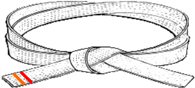

- Complete 2 to 3 classes a week consistently
- Complete 16 Classes minimum before testing for your next Belt.

Be able to correctly demonstrate:
- White Belt Fundamentals
- 10 Count Punch/Block Drill By the count.
- Three-step Sparring- Number 1, (Alone)

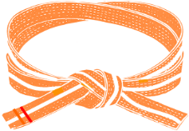
- Complete 2 to 3 classes a week consistently.
- Complete 24 Classes minimum before testing for your next Belt. (If a student excels and shows proficiency to be promoted to the next rank, he/she may be promoted without having the required number of classes.)

Be able to correctly demonstrate:
- White/Orange Belt Fundamentals (See your goals & objectives sheet you received with this Belt.)
- 10 Count Punch/Block Drill By the count.
- Three-step Sparring- Numbers 1 and 2, (Alone)
- demonstrate your Form: Kee Cho

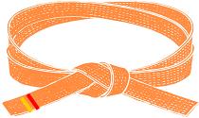
- Complete 2 to 3 classes a week consistently

- Complete 24 Classes minimum before testing for your next Belt. (If a student excels and shows proficiency to be promoted to the next rank, he/she may be promoted without having the required number of classes.)

Be able to correctly demonstrate:
- Orange Belt Fundamentals (See your goals & objectives sheet you received with this Belt.)
- 10 count Punch/Block Drill
- 10 Count Kick Drill- 1st six kicks.
- Three-step Sparring- Numbers 1 and 4, or 1-step Sparring 1-4
- demonstrate your White/Orange Belt and Orange Belt forms, Ki Cho & Dan Gun

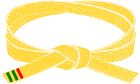

- Complete 2 to 3 classes a week, consistently.

- Complete 24 Classes minimum before testing for your next belt. (If a student excels and shows proficiency to be promoted to the next rank, he/she may be promoted without having the required number of classes.)

Be able to correctly demonstrate:

- Yellow Belt Fundamentals (See your goals & objectives sheet you received with this Belt.)
- 10 count kicking drill- all 10 kicks.
- Your Forms: Dan Gun & Do San
- Three-step Sparring/1-step Sparring
Waldorf Martial Arts Testing Requirements
Intermediate Level


- Complete 32 Classes before your belt test. (If a student excels and shows proficiency to be promoted to the next rank, he/she may be invited to test without having the required number of classes.)

- Come to 2 to 3 A/B Day classes a week consistently; make up any missed classes.

Be able to correctly demonstrate:

- Green Belt Fundamentals- (See your goals & objectives sheet you received with this Belt.)
- Forms: Do San and Won Yo
- 1-Step Sparring
- Light-Contact, Controlled Free Sparring
- Board Breaking- Palm Heel Break or Elbow Break at your test for Blue Belt.


- Complete 32 Classes before your next Belt Test. (If a student excels and shows proficiency to be promoted to the next rank, he/she may be invited to test without having the required number of classes.)

- Complete 2 to 3 A/B Day classes a week consistently; make up any missed classes.

Be able to correctly demonstrate the following at your next test:
- Double Kicking- (See your goals & objectives sheet you received with this Belt.)
- Forms: Won Hyo and Yul Guk.
- One-step Sparring
- Light-Contact, Controlled Free Sparring
- Board Breaking- Front Kick or Side Kick at your test for Blue/Purple Belt.

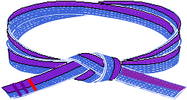
- Complete 32 Classes before your next Belt Test. (If a student excels and shows proficiency to be promoted to the next rank, he/she may be invited to test without having the required number of classes.)

- Complete 2 to 3 A/B Day classes a week constantly; make up any missed classes.

Be able to correctly demonstrate the following at your next test:
- Double Kicking (See your goals & objectives sheet you received with this Belt.)

- Forms: Yul Guk & Chun Goon.
- One-step Sparring
- Light-Contact, Controlled Free Sparring
- Board Breaking- Knife Hand Strike and Side Kick or Ax Kick at your test for Purple Belt.
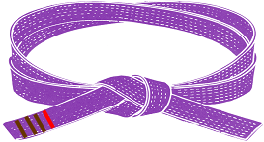
- Complete 32 Classes before your next Belt Test. (If a student excels and shows proficiency to be promoted to the next rank, he/she may be invited to test without having the required number of classes.)

- Complete 3 A/B Day classes a week consistently; Make up any missed classes.

Be able to correctly demonstrate the following at your next test:
- Jump Kicking: Jump Front Kick, Jump Round Kick, Jump Side Kick

- Forms: Chun Goon & Tei Gei
- One-step Sparring
- Light-Contact, Controlled Free Sparring
- Board Breaking- elbow strike and Skip Side Kick or Hook Kick at your test for Brown Belt
Waldorf Martial Arts Testing Requirements
Advanced Level

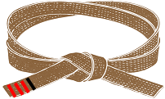
- Complete 32 Classes before your next Belt Test. (If a student excels and shows proficiency to be promoted to the next rank, he/she may be invited to test without having the required number of classes.)

- Come to 3 Classes a week consistently, make up any missed classes.

Be able to correctly demonstrate the following at your next test:
- Kicking: Jump Spin Side Kick, Spin Heel Kick, Spin Crescent Kick
- Advanced 1-steps
- Forms: Kee Cho, Chun Gee, Dan Goon, Doe Sahn, Tei Gei, Hwa Rang
- Light-Contact, Controlled Free Sparring
- Board Breaking- any 2 kicks; one with each leg, at your test for Red Belt
- Physical Requirements Push-ups & Sit-ups- 25
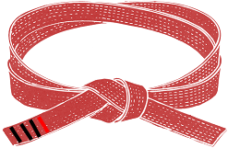
- Complete 32 Classes by your Test. (If a student excels and shows proficiency to be promoted to the next rank, he/she may be invited to test without having the required number of classes.)

- Come to 3 to 4 A/B Day classes a week consistently; make up any missed classes.

Be able to correctly demonstrate the following at your next test:

- Kicking: Jump Spin Side Kick, Spin Heel Kick, Spin Crescent Kick, Spin Hook Kick, Flying Side Kick
- Advanced 1-steps
- Forms: Won Yo, Yul Guk, Chun Gun, Wha Rang, Chung Moo
- Light-Contact, Controlled Free Sparring
- Board Breaking- any hand/elbow strike and any 2 kicks; one with each leg. One must be a spinning kick.
- Physical Requirements Push-ups & Sit-ups- 25

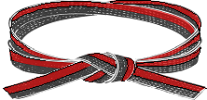
- Complete 32 Classes before your Black Belt cycle begins. Complete 48 more classes while in the Black Belt cycle. (If a student has the required number of classes, however, we deem that the student is not yet ready to test, we will hold him/her back until he/she meets our standards to test for Black Belt. Likewise, if a student excels and shows proficiency to be promoted to the next rank, he/she may be invited to test without having the required number of classes.)

- Attend, once a month, a Mandatory Black Belt Cycle Class on Saturday; 4 classes in total

- Pass a Pre-test Exam halfway through the Cycle. Requirements: All curriculums from white belt to red/black belt.

Be able to correctly perform the following:

- Fundamental movements demonstration
  - 1-steps demonstration

- Patterns Demonstration- all 10 patterns. Chun Gi to Chung Moo

  - Ho Sin Sool (Self Defense) Demonstration
- Free Sparring Demonstration: 3 to 5 rounds of high-level sparring.
- Board Breaking Demonstration- Any Hand Strike. Any 2 kicks; 1 with each leg. 1 must be a spinning kick.
- Physical Requirements Demonstration: Push-ups & Sit-ups- 4 sets of 25

WALDORF MARTIAL ARTS TESTING REQUIREMENTS FOR BLACK BELT
1st Dan Belt Curriculum
Minimum Time at Rank: 2 years
Must attend a monthly mandatory Black Belt Seminar during each of the 4 months of the Black Belt Cycle.
Forms: 3 lower belt forms and Gae Beck, Po Eun, Kwang Gae.
Weapons Form-1, your choice
One-step Sparring
Ho Sin Sool
Free-Sparring
Board Breaking: Any 2 hand strikes. Any 2 kicks; one with each leg. One must be a spin, jump scissors, or jump spin.

2nd Dan Black Belt Curriculum
Minimum Time at Rank: 2 Years
Must attend a monthly mandatory Black Belt Seminar during each of the 4 months of the Black Belt Cycle.
Forms: 3 lower belt forms and Eui Am; Choong Jang; Ko Dang
Weapons Form- 2 , your choice
One-step Sparring
Ho Sin Sool
Free-Sparring
Board Breaking Any 2 hand strikes. Any 2 kicks. One must be a jump spin, flying side kick, or flying obstacle kick.

3rd Dan Black Belt Curriculum
Minimum Time at Rank: 3 Years
Must attend a monthly mandatory Black Belt Seminar during each of the 4 months of the Black Belt Cycle.
Forms: 3 lower belt forms and Sam Il; Yoo Sin; Choi Yong
Weapons Form – 3, your choice
One-step Sparring
Ho Sin Sool
Free-Sparring
Board Breaking Same as 2nd Dan

4th Dan Junior Master Black Belt Curriculum
Minimum Time at Rank: 4 Years
Must attend a monthly mandatory Black Belt Seminar during each of the 4 months of the Black Belt Cycle.
Forms: 3 lower belt forms and Yon Gae, Ul Ji, Moon Moo
Weapons Form Same as 3rd Dan.
6th Dan Master Black Belt
Minimum Time at Rank: 6 Years
Demonstration is optional.

7th Dan Senior Master Black Belt
Minimum Time at Rank: 7 Years
Demonstration is optional.

8th Dan Senior Master Black Belt
Minimum Time at Rank: 8 Years
Demonstration is optional.

9th Dan Grand Master Black Belt
One-step Sparring
Ho Sin Sool
Free-Sparring
Board Breaking Same as 2nd Dan.

5th Dan Master Black Belt Curriculum
Minimum Time at Rank: 5 years
Must attend a monthly mandatory Black Belt Seminar
during each of the 4 months of the Black Belt Cycle.
Forms: 3 lower belt forms and So San, Se Jong, Tong Il
Weapons Form Same as 3rd Dan.
One-step Sparring
Ho Sin Sool
Free-Sparring
Board Breaking Same as 2nd Dan.

Five Tenets of Taekwondo
The Five Tenets of Taekwondo
These five tenets serve as the foundation for the ethical and moral aspects of Taekwondo, guiding practitioners not only in their martial arts journey but also in their everyday lives. By incorporating these principles into your training and lifestyle, students aim to become not only skilled martial artists but also individuals of character and integrity.
Courtesy, integrity, perseverance, self-control and indomitable spirit should guide all students and instructors - on and off the mat. Our members should amplify these five tenets of Taekwondo, and the values of Traditional Taekwondo, to ensure a safe, respectful and welcoming martial art and sport for all.
Courtesy (Ye Ui)
This tenet emphasizes the importance of showing politeness, respect, and consideration toward others. In Taekwondo, students are taught to be courteous both inside and outside the dojang (training area). Courtesy is essential for fostering a positive and respectful training environment, promoting good sportsmanship, and building character.
Integrity (Yom Chi)
Integrity in Taekwondo involves maintaining a sense of honesty, sincerity, and moral principles. Practitioners are encouraged to be truthful, uphold a strong code of ethics, and demonstrate integrity in all aspects of their lives. This tenet emphasizes the importance of doing what is right, even when faced with challenges or difficult decisions.
Perseverance (In Nae)
Perseverance is the quality of persistence and determination in the face of challenges and obstacles. In Taekwondo, students learn to overcome difficulties, set and achieve goals, and stay committed to their training. Perseverance is crucial for personal development, skill improvement, and achieving success in both martial arts and life.
Self-Control (Guk Gi)
Self-control involves exercising restraint over one's actions, emotions, and impulses. In the context of Taekwondo, practitioners are taught to control their movements, thoughts, and behaviors. Developing self-control helps prevent the misuse of martial arts skills and contributes to maintaining a safe training environment. It also encourages practitioners to approach conflicts with a calm and composed mindset.
Indomitable Spirit (Baekjul Boolgool)
Indomitable spirit refers to an unyielding and unwavering determination, especially in the face of adversity. Taekwondo students are encouraged to develop a strong and resilient spirit that enables them to overcome challenges, fear, and self-doubt. This tenet inspires practitioners to face difficulties with courage, maintain a positive attitude, and never give up on their goals.

The Taekwondo Oath
As a dedicated student of the martial arts:
I will live by the tenets of Taekwondo: Courtesy, Integrity, perseverance, self-control, and Indomitable Spirit
I will respect my seniors, and instructors. My parents and my fellow students.
I will never misuse Taekwondo.
I will be a champion of freedom and justice.
I will build a more peaceful world.

Korean terminology

uniform = do bok
taekwondo school = do jang
attention = chah-ree-ut
bow = kyung-eh
ready = joon bee
begin = shee-jak
stop = go mahn
return to ready = bah-roh
at ease = show

forms = hyungs
breaking = kyuk pa
meditation = muk num
1-steps = il sook daeleon
3-steps = sam sook daeleon
free sparring = jy yew daeleon
self-defense = ho sin sool

numbers
one = hanah
two = duhl
three = set
four = net
five = dah-sut
six = yah-sut
seven = ill-gop
eight = yo-dul
nine = ah-hop
ten = yul

kick = chahgi
block = mahki
front stance = chun gul jahsi
back stance = who gul jahsi
riding stance = kima jahsi
front stretch kick = ap cha leg gi
front snap kick = ap cha gi
round kick = dollyo cha gi
side kick = yup cha gi
spin side kick = dwi dora yup cha gi
spin heel kick = dwi whorigi
flying side kick = twim yoe yup cha gi
knife hand = soo do tah leggi
inverted knife hand = ahn soo do
side block = yup mahki
high block = han dan mahki
low block = san dan mahki
elbow smash = pal coop
ridge hand = yuk soo do
spear hand = kwon soo gong gyuck
out to in block = ahnaeso pakaro mahki
in to out block = pahkaeso ahnaro mahki

head master = kwon ja nym
master instructor = sa bum nym
senior student = san bae nym
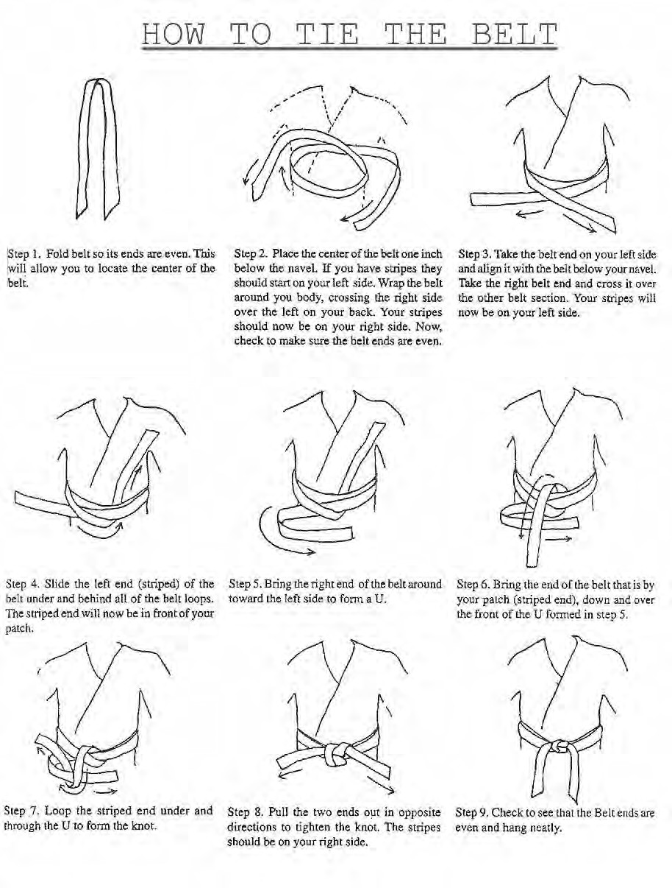

17A

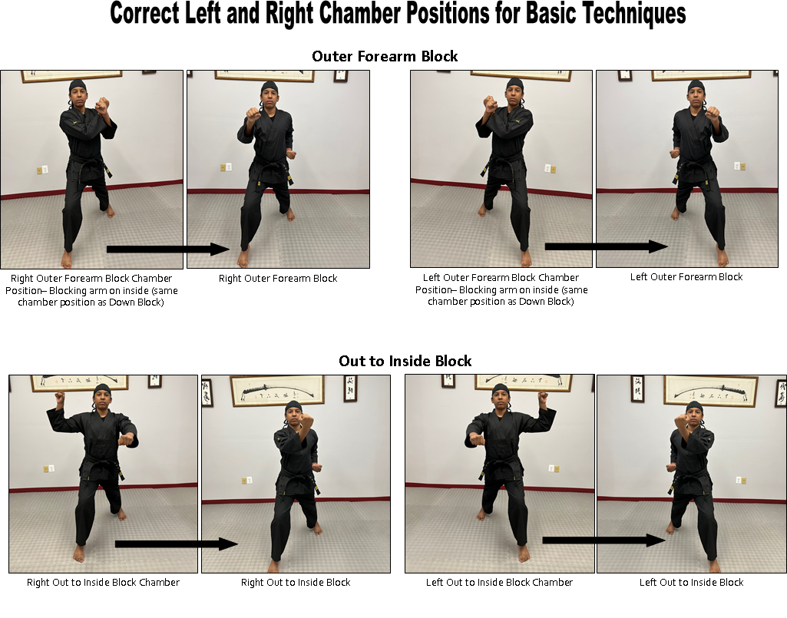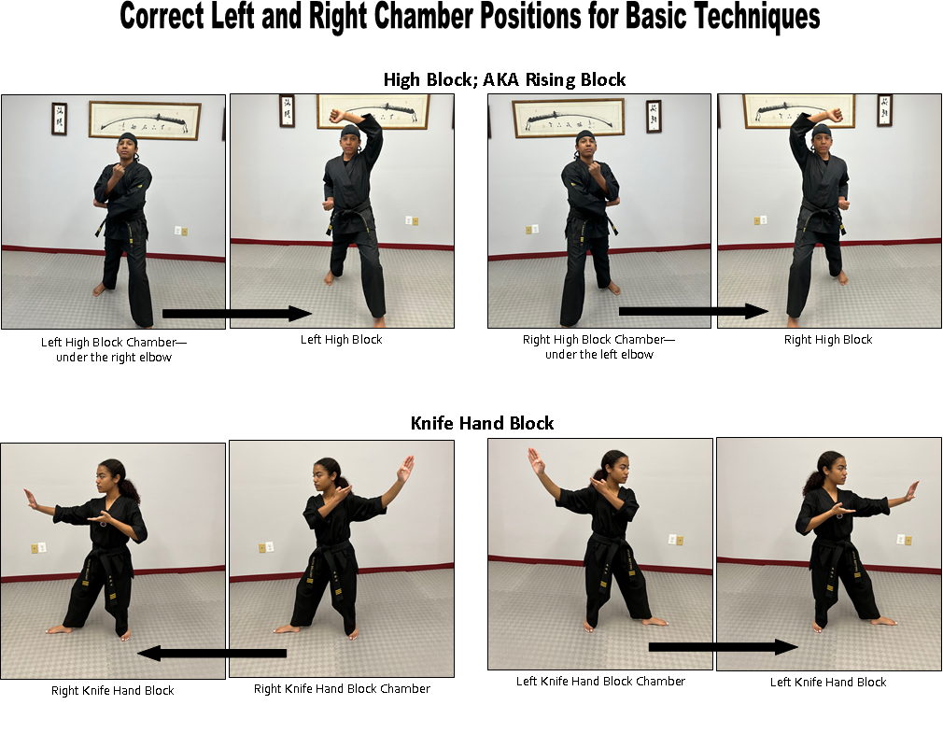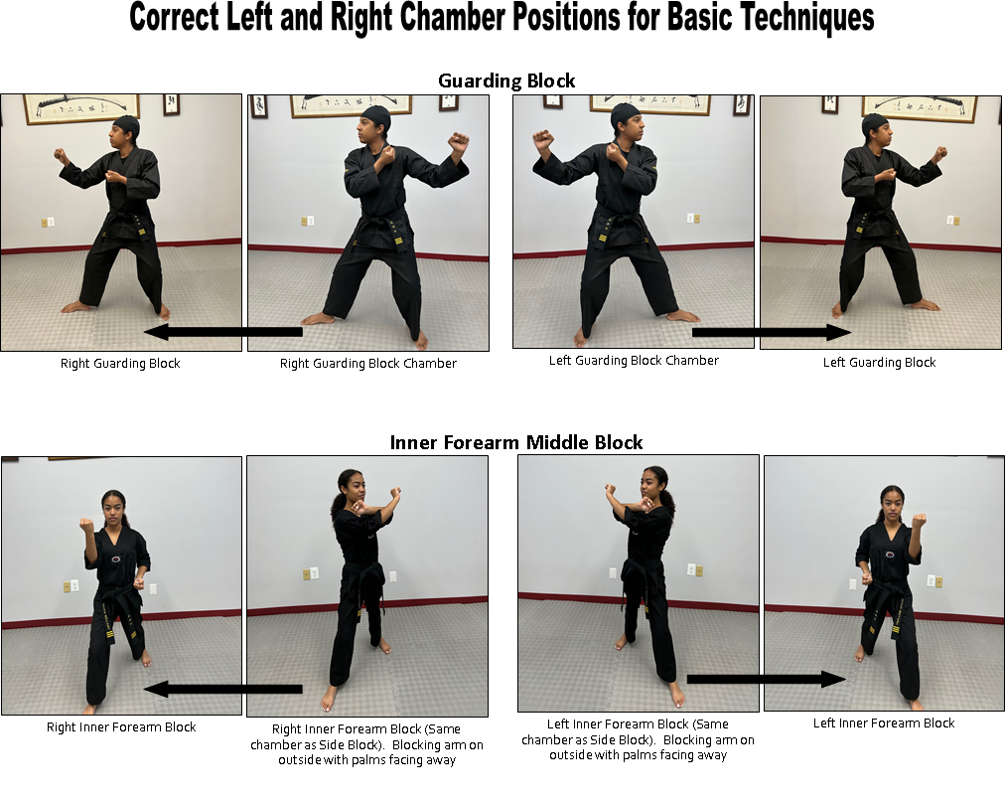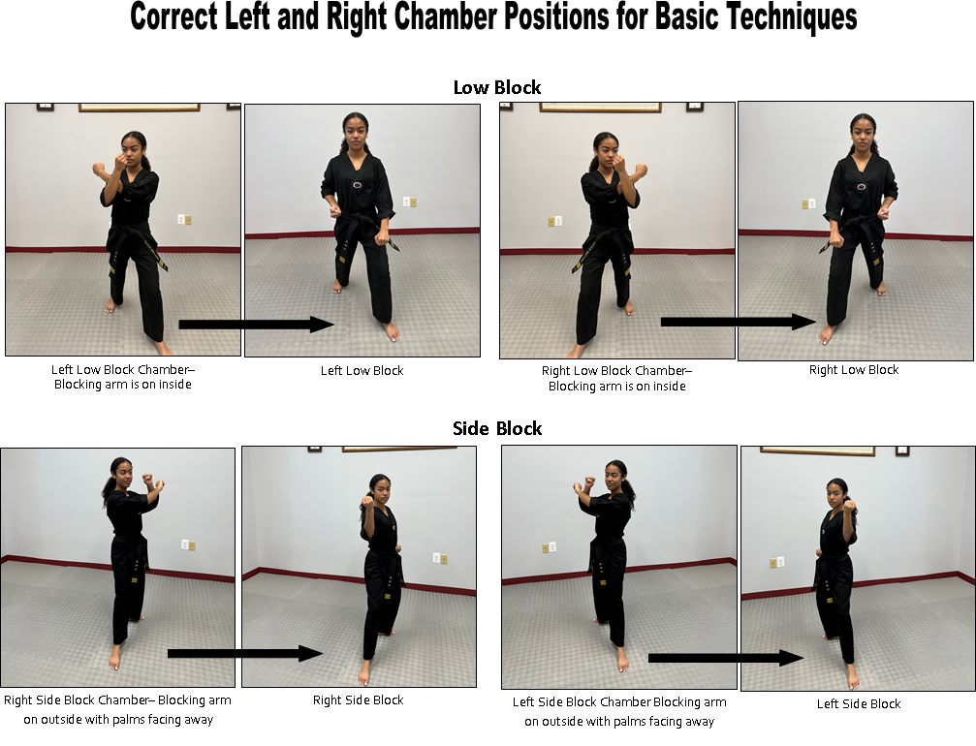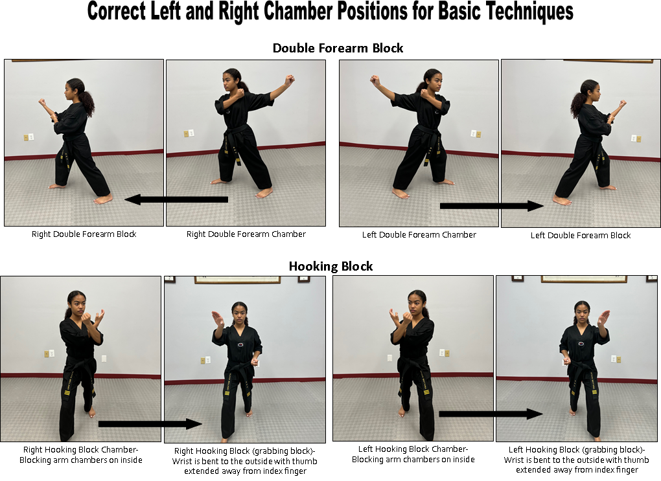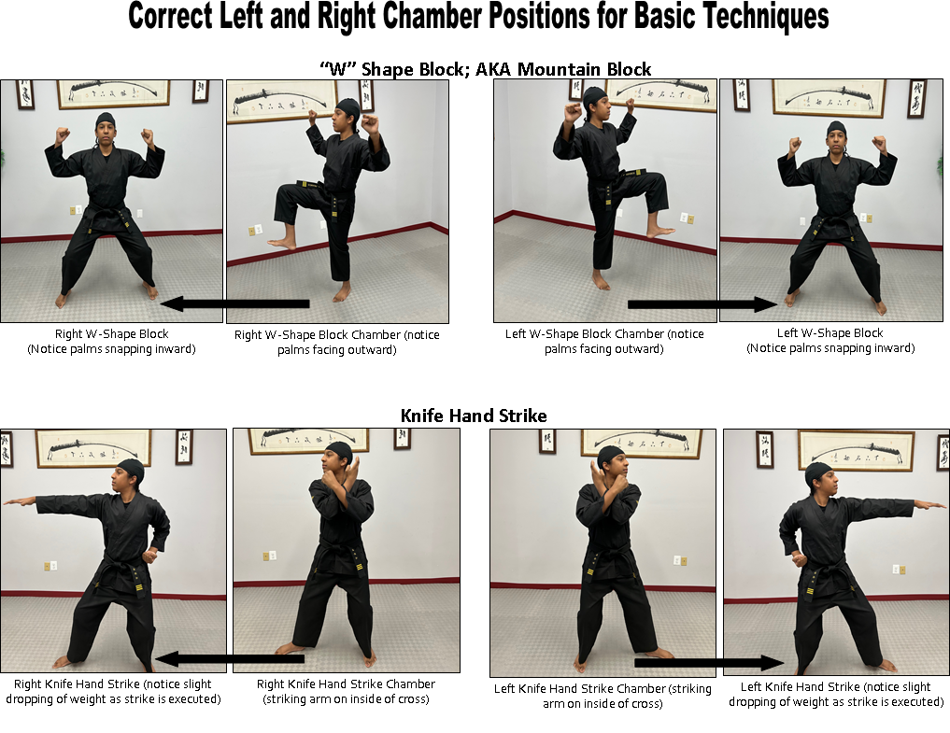
21
10-Count Drills
10 count Punch/Block Drill—Horse Riding Stance:
Starting with the left hand:
2 punches; Kiop on the 2nd punch.
2 high blocks; Kiop on the 2nd block
2 low blocks; Kiop on the 2nd block
2 side blocks; Kiop on the 2nd block
2 outside-in blocks. ; Kiop on the 2nd block

10 count Kick Drill
1. Step back with right leg into back stance while executing guarding block, execute a rear-leg front kick (right leg) returning foot back behind you. Turn to the rear and do the same kick with the left foot returning it back to the rear.

2. Turn to front into back stance while executing guarding block, execute a rear-leg right leg round kick, setting foot down in front of you. Then do the same kick with the other foot, setting it down in front of you,

3. Turn behind into guarding block, back stance, and do front leg (right) leg step behind side kick, setting foot down in front of you. Turn around and do the same kick with the other foot, landing in a left leg forward back stance guarding block.

4. From a left leg forward back stance guarding block, do right leg crescent kick and return the foot to the back into back stance and guarding block. Then with the same foot (right) execute a moon-in kick and set the leg down in the front.

- From a right leg forward back stance guarding block, do left leg crescent kick and return the foot to the back into back stance and guarding block. Then with the same foot (left) execute a moon-in kick and set the leg down in the front. Kiop!

Step Sparring

Step sparring is pre-arranged partner drills, designed to develop razor-sharp defensive reaction skills as well as develop one’s spatial awareness, distancing, and hand/foot - eye coordination. One-steps, practiced for years, become second nature.

3-Step Sparring

Procedure

On the command “Cheryuit” partners Face each other at attention.

On the command “Kung Yae” they bow to one another.

On the command “Joon Bi” they go to ready position.

On the command “Sea-jack” the low rank (the attacker) steps back with his right leg into a back stance while executing a forearm and Kiops loudly to signal his partner that he is ready to attack.

When the higher rank (the defender) is ready , he will Kiop loudly to signal the attacker he is ready to receive the attack.

The attacker then steps forward with his right leg as he executes a high section fore-fist punch at full speed.

As the attacker steps forward and punches, the defender reacts by stepping backwards with his right leg and blocks the punch with a knife hand guarding block.

The attacker steps forward 2 more times with a high-section punch and the defender steps back 2 more times and blocks the attack.

As the attacker punches for the 3rd time, the defender reacts with his knife hand guarding block and follows with a counter-attack. He Kiops on the last move of the counter-attack.

Then, both return to Joon Bi position. The attacker steps back while the defender steps forward.

They then switch roles, and the high rank becomes the attacker; the low rank becomes the defender and the drill repeats.

White Belt to Yellow Belt
Defense 1: 3x knife hand block + reverse punch.

Defense 2: 3x knife hand block + step back and Front kick (right leg).

Defense 3: 3x knife hand block + front leg side kick (left leg) and + reverse punch.

Defense 4: 3x knife hand block + step back and round kick (right leg) + knife hand strike (right hand).

Defense 5: 3x knife hand block + do front foot front kick (left foot) + set foot down next to support leg (right) and execute right foot round kick + right hand Backfist.

1-Step Sparring

Procedure

On the command “Cheryuit” partners Face each other at attention.

On the command “Kung Yae” they bow to one another.

On the command “Joon Bi” they go to ready position.

On the command “Sea-jack” the low rank (the attacker) steps back with his right leg into a back stance while executing a forearm and Kiops loudly to signal his partner that he is ready to attack.

When the higher rank (the defender) is ready , he will Kiop loudly to signal the attacker he is ready to receive the attack.

The attacker then steps forward with his right leg as he executes a high section forefist punch at full speed.

As the attacker punches the defender reacts with his defensive response and Kiops on the last move of the response.

Then, both return to Joon Bi position. The attacker steps back while the defender steps forward.

They then switch roles and the high rank becomes the attacker; the low rank becomes the defender and the drill repeats.

Green Belt to Purple Belt 1-20

- Block (with right arm) blocking his punching arm. Cross arms and deliver a knife hand strike step towards attacker with right foot into a back stance as you execute an out-to-in forearm (right hand) to attacker jaw. Kiop!
- Hop to your right into a front stance (left leg forward) as attacker punches. Execute right leg front snap
kick to attacker’s stomach or face (whichever you prefer). Set the right leg down into a horse-riding stance facing the attacker and execute a triple punch combination (right to stomach; left to stomach; right to face). Kiop!
- Pick up the left foot and slide 45 degrees to the left into a horse-riding stance and execute an out-to-in palm heel block with the left palm (blocking the attackers punching arm). Execute a triple punch combination (right to ribs; left to ribs; right to temple). Execute roundhouse kick with right leg to stomach. Kiop!

- Step towards attacker with your left leg into a front stance as you execute a high block with your left forearm, blocking his punching arm. Keeping the left arm in the high block position, execute a right middle punch to attacker’s stomach. Recoil right arm (you just punched with) and execute a right palm heel strike to attackers’ upper lip. When delivering the palm heel strike the left arm recoils to the left side hip. Kiop!

- As the attacker punches, execute, from a ready stance (joon bee stance), a right leg in-to-out crescent kick blocking his punching arm to the side. Set the right foot down behind the left foot and shuffle forward as you execute a double punch combination (left to face; right to face). Execute roundhouse kick with your right leg to attacker’s stomach or face (whichever you prefer). Kiop!
- As the attacker punches, execute a side kick to his rib section with your right foot. Set the right foot down into a horse-riding stance to the outside of his front leg. Your back will be to the attacker. Cross your arms and deliver a knife hand strike to his rib section with right hand. Cross arms again and deliver a knife hand strike to his jaw (again with right hand). Pivoting feet and turning upper body counterclockwise, cross arms and deliver left knife hand strike to attacker’s stomach. Step away from attacker with right leg into a back stance (left leg forward) as you deliver a left knife hand block to his punching arm. Execute a roundhouse
kick with right foot to attacker’s face or stomach (whichever you prefer). Kiop!

- Hop to the right and execute a front snap kick with the right foot to the stomach or face. Set the foot down and execute a jump scissors front kick with the same foot to the chin. Kiop!
- Step 90 degrees to the left and execute a side kick with right foot to attacker’s ribs. Set the right foot down into a front stance (right leg forward) and execute a right in-to-out forearm block to the attackers punching arm. Execute a left punch to his ribs. Kiop!
- Step 45 degrees to right into a horse-riding stance simultaneously executing a knife hand block (left hand) to attacker’s punch and an inverted knife hand strike to his jaw. Shift weight to a back stance (left leg forward) as you execute a fore elbow strike to attacker’s jaw with your right elbow. Grab attackers punching arm with your left hand. As you bring your right foot to your left and pull him towards you with your left grabbing hand, deliver a right knife hand strike to his opposite jaw. Kiop!
- As opponent punches, slide toward him with your left foot into a back stance while blocking his punching arm with a left side block. With right hand, punch to solar plexus with left hand, punch to upper lip with left front foot side kick to body or face and Kiop!

- Take a half step right with your right foot and move your left foot towards the attacker’s left shoulder so that you are in a back stance, left foot forward. As you are moving into the back stance, execute a left knife hand strike to the attacker’s jaw, drop the hand straight down to the shoulder and execute a right upset punch to the shoulder right below your hand. Jump straight back and execute a right round house kick to ribs or face. Kiop!
- Deliver a Moon-in kick with right leg to attacker’s punching arm. Without setting the foot down, execute right side kick to stomach or face. Set your right foot down in front of you into a front stance and execute a left reverse punch. Kiop!
- Stepping, with your left foot, 90 degrees to the right, execute a side kick with the left leg to attacker’s face. Set the foot down next to your supporting leg and execute a right leg spin side kick. Kiop!

- As attacker punches, deliver a left leg front kick. Set the foot down next to the supporting foot and execute a right leg side kick. Set the foot down next to the supporting foot and execute a left spin side kick. Set the foot down next to the supporting foot as you spin around and block the punching arm with a right palm heel and round house kick with the right leg. Kiop!

- Step towards the attacker with your right leg into a back stance and execute an out/ in forearm block. Palm facing you. Pull blocking arm back and deliver a fore elbow strike to attacker’s jaw with the right elbow. Pull arm back and deliver a backfist strike to attacker’s temple with a right backfist. Without moving feet, pivot counterclockwise and deliver a spin back elbow strike to floating rib. Pick up right leg and step back away from attacker into a forearm guarding block position blocking punching arm if necessary. Finish with a right round house kick to the attacker’s ribs or face. Kiop!

- Deliver front snap kick with left foot to attacker’s stomach. Deliver jump scissors crescent kick with left foot to attackers punching hand. Deliver roundhouse kick to side of face with right foot and Kiop!

- Deliver crescent kick with right leg to attackers punching hand. Deliver roundhouse kick with left leg to side of face. Deliver spin side kick with right leg and Kiop!
- Slip 90 degrees to your right, deliver a left leg side kick. Set the left leg down so you are in a left-leg-forward front stance facing the attacker. As you set the foot down, deliver a left knife hand block to his punch arm followed by a right-hand reverse punch to his solar plexus. With right leg, step in front of the attacker and to his right side as you clear his punch with a double forearm block. Pivoting counterclockwise into a back stance with left foot forward, deliver a knife hand strike to his upper lip. Shifting your weight into a front stance with left foot forward, deliver a reverse ridge hand strike to bridge of nose. With right leg, deliver a roundhouse kick to face and Kiop!
- Step to the right and execute a side kick with your left leg to either attacker’s stomach. Spinning clockwise, set the left foot down behind your right. Pick up the right front foot and execute a round house kick to attacker’s face. Set the right foot down into a front stance and execute a left middle punch to solar plexus of attacker. Kiop!
- Deliver a left leg crescent kick to punching arm. Deliver a right leg roundhouse kick to side of face. Deliver a left leg spin heel kick to face. Kiop!

Brown Belt and Higher- 21 to 40

- Slip left to avoid punch and execute elbow dislocation*right elbow to rib* step thru and left back elbow to rib*finish with technique of choice. KIOP!

- Slip left to avoid punch and execute elbow dislocation*with right hand, grab top of partner’s fist circling it in a downward counterclockwise motion. As you step through an under the arm, grab the fist with your other hand too, cranking his wrist to create wrist pain as well. Once you are behind your partner, put him in a rear arm lock. Let go of his hand with your left hand and put him in a tracheal choke with your forearm. Finish with a takedown by pulling with your left arm and pushing his lower back forward with
your right arm. (don’t let go of the arm lock.) KIOP!

- Right leg moon-in kick*left leg spin side kick*left punch-right punch* right leg jump spin kick. KIOP!

- As opponent punches, stepping with right foot, slip inside and block punch with twin forearm block. Then stun him with a right Knife hand strike to side of neck or jaw hinge. Then, quickly, slide your left arm under and around your partner’s arm at his shoulder. Grab your left wrist with your right hand and explosively pull his shoulder/arm to your body (trapping arm in an arm bar), turning his elbow and shoulder over as you do this. Circle him down to the ground keeping the shoulder locked tight to your body. KIOP!

- Step straight in while executing left knife hand block and right ridge strike to groin* slide forward a little and execute right upward elbow strike to chin*finish with a downward palm heel strike to bridge of nose. Add a kick if you’d like! KIOP!

- 26. Slip left 45⁰ to left-leg forward front stance and execute a side block with the right ridge hand—staying in the left-leg forward front stance, execute a right knife hand strike to the floating rib-- shift to a riding stance and execute a right fore-fist punch--shift to a right leg forward front stance as you execute a left hooking block, clearing his arm out to the side--shift back to a left leg forward front stance executing an right inverted knife hand strike to his jaw. Finish with a right leg crescent kick in front of his face (target is the right jaw/temple). KIOP!

- With left leg, step 45⁰ across to the right into a walking stance and immediately execute a jump spinning heel kick with right leg- then execute a right-left leg flutter round kick. Set the left leg down in front and execute a right inverted knife hand strike to his neck. Finish by grabbing the back of the neck with your right hand, sliding forward, execute a left fore-elbow strike. KIOP!

- Left leg downward moon-in block to punching arm as it reaches full extension. Right leg spin heel kick- right leg jump spin heel kick. KIOP!

- Side block*reverse punch*left leg defensive side kick*right leg high section round kick*slide back and right leg jumping scissors spin side kick. KIOP!

- Slip 45⁰ left, and, with the left hand, in a downward sweeping motion, catch your partner’s punch as it reaches full extension. Continue pulling it downward as you slide forward and execute a right horizontal elbow strike nose bridge/chin. Now grab the punching hand with your right hand and counter twist in a clockwise motion to the left, placing him in a painful wrist lock and either breaking the wrist or taking him down. KIOP!

- Step straight into a left leg forward Back Stance, while executing a left Square-Block with Knife hand to attacker’s punch. Then execute a right inverted knife and strike (palm up) to jaw, drawing the left arm back to your right shoulder. With left knife hand, execute a strike to neck. Shift to a front stance and execute a right reverse punch to solar plexus. Shift to back stance and execute a left leg side kick to ribs. KIOP!

- Step backwards, away from attacker, with the right leg into a left leg forward back stance while you execute an inward block with the palm heel. Move the front foot back half the distance to your back foot (right leg) and execute a right leg spin back kick. Set the kicking leg down in front of the supporting leg at shoulder width, and with the left leg execute a an inward “moon” kick to the attackers punching arm. Then execute, at a 45-degree angle to the right of your opponent, a scissors jump spinning moon kick across the front of the attacker’s face! KIOP!

- Step diagonally to your left into a left leg forward front stance while executing a hooking block with the right hand to the attackers punching arm. Execute a right leg round kick to his solar plexus. Set the kicking leg down shoulders width in front of your left leg, and then sliding your left leg behind your opponent’s front leg into a back stance as you execute a hammer fist strike to his solar plexus. Slip to a front stance and finish with a reverse punch to the floating rib. KIOP!

- Step diagonally to your left into a left leg forward front stance while executing a hooking block with the right hand to the attackers punching arm. Execute a right leg round kick to his solar plexus. Set the kicking leg down shoulders width in front of your left leg, and then execute a spinning crescent kick to the side of his head.

- As attacker begins to punch, with your right leg, step diagonally to your left and to the outside of his front leg as you execute an inward block with your right arm. Then execute a counter-clockwise spinning elbow with your left arm to his upper-lip. Perform the block and strike in a continuous motion. Now, pick up your right leg and spin (180⁰) counterclockwise away from the attacker into a front stance while executing right reverse punch to his solar plexus. To finish, pick up your left (front) foot and spin (180⁰) clockwise away from the attacker into a right leg forward back stance with guarding block. Execute a jump side kick to his neck. KIOP!

- Execute a left leg downward moon-in block to attacker’s punching arm as it reaches full extension. Set the foot down shoulders distance in front of your right leg and immediately execute a right leg spin heel kick to the right-side temple of the attacker. Stop the kick in mid-air, next to his temple. Then set the right foot down diagonally to your right and to the attacker’s left, into a right leg forward front stance and execute a left leg twisting kick to the left jaw of the attacker. KIOP!

- As attacker punches, slip diagonally to your left with your left leg into a riding stance and executing a pushing block with the left palm heel. Follow with a right punch to floating rib. The execute a right leg twisting kick to the right side of his head to the area just below his ear (back side of his jaw). Set the foot down slightly in front of the left foot and execute a left leg spin hook kick (under his punching arm) to his sternum. KIOP! (Variation: execute the spin heel kick across the right side of his head following through (360⁰) all the way.)

- Choon Jang: As attacker punches, step back with right leg and execute a knife hand block. Follow with a right leg front kick to solar plexus. Set foot down in front stance as you execute flat fingertip thrust to throat. Drop to floor onto left knee and execute a right round kick to inner thigh. Come up to left kneeling stance and execute a right punch to groin. Standing up, step towards the attacker and execute a rear elbow strike with your left elbow. Spin away in a clockwise motion and come to guarding block. KIOP!

- As attacker punches, slip diagonally to your left with your left leg into a back stance while executing a pushing block with the left palm heel and an upset punch to ribs simultaneously. With your left hand trap the attackers punching arm in a downward motion as you execute a right elbow attack to his jaw/chin area. With your left leg, stepping away in a clockwise motion, finish with a right spin crescent kick to attacker’s jaw. KIOP!

- As attacker punches, step in towards him with right leg and execute simultaneously a left block to attack and right strike to side of neck/jaw (as in Ul Ji). Follow with a left palm heel strike to chin, a right vertical punch to liver, a left knife hand strike to side of neck, and a right inverted knife hand strike to side of neck. Finish by grabbing the back of his head with both hands and pulling him into a knee strike (right or left; your choice). KIOP!

HYUNG (Forms or Patterns)

Hyung (patterns or forms) are an important part of the Art of Taekwon-Do. They provide the ultimate discipline of mind and body of the practitioner. A Hyung consists of various combinations of basic techniques into systematic and logical movements of attacking, defending, jumping, gliding and so on, to an imaginary opponent. The design of the Hyung is to eventually enable the student to perform with grace and rhythm, while at the same time with power, speed, balance, control of body and mind, and efficient breathing. This ultimate achievement is only possible after hours of consistent training. Hopefully the mastery of Hyung enables the practitioner to sharpen all aspects of the techniques, understand the flow of energy in the body, and develop a strong and guided mental aspect in character building. All these acquired aspects will lead to an impenetrable spirit and develop a strong sense of singleness of purpose to combat problems and the pressures of life.
There are 24 patterns in the official ITF “Chang Hon” syllabus, which represents the 24 hours in a day. The names of these patterns refer to events or important people in Korean history. Features of the patterns may also have historical references, such as the number of moves, the diagram, the way the pattern ends etc. Hyung stress the development of correct basics. Each block, strike, and stance must be without flaw. If correct execution of a technique in a hyung is overlooked, then the student will be off balance, thus greatly reducing the amount of power he can generate. The technique would be, to a great extent, ineffective due to lack of power and focus. Since advanced combinations consist of basic (ki bon pronounced "kee bon") movements, the practitioner must have solid basics.
Basic patterns (ki bon hyungs) consist of a few blocks and strikes combined with little in the way of footwork. This early integration of basic techniques helps the student develop rhythm, power, and control. As the student progresses through the ranks, the hyungs become increasingly complex. Footwork and body movement intensify until movement becomes more natural and the students’ techniques become fluid. It is the coordinated effort of the mind and body, internal and external powers, and reaching for perfection which make hyungs an integral part of Tae Kwon Do.
General Performance Tips
- Patterns should begin and end at exactly the same spot. This will indicate the performer’s accuracy.
- Correct posture and facing must be maintained at all times.
- Muscles of the body should be either tensed or relaxed at the proper critical moments in the pattern.
- The pattern should be performed in a rhythmic movement with an absence of stiffness.
- Movement should be accelerated or decelerated as necessary.
- Each pattern should be perfected before moving to the next.
- Students should know the purpose of each movement.
- Students should perform each movement with realism.
- Attack and defense techniques should be equally distributed among right and left hands and feet.
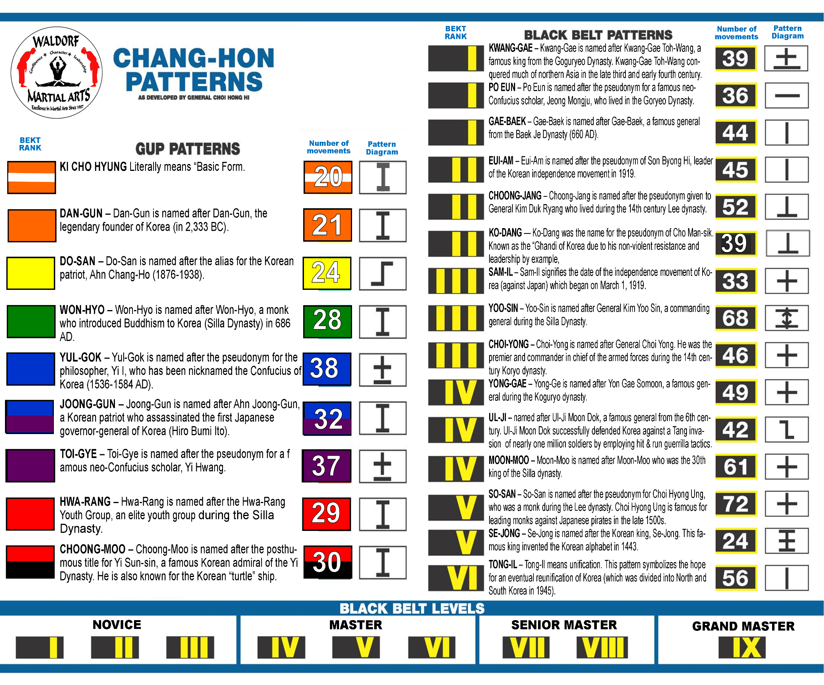
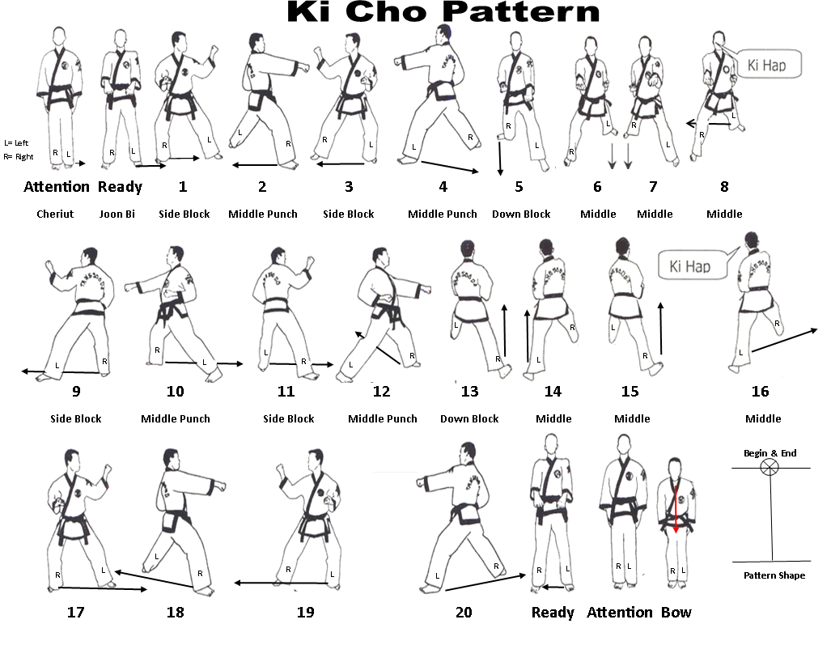

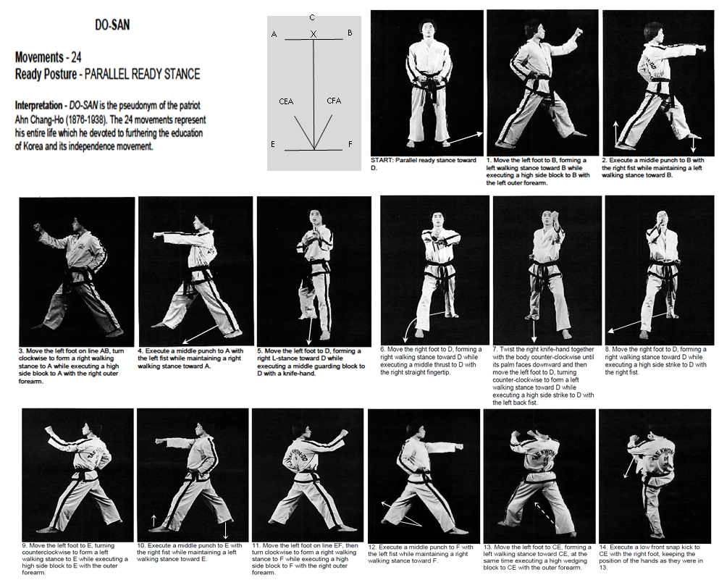
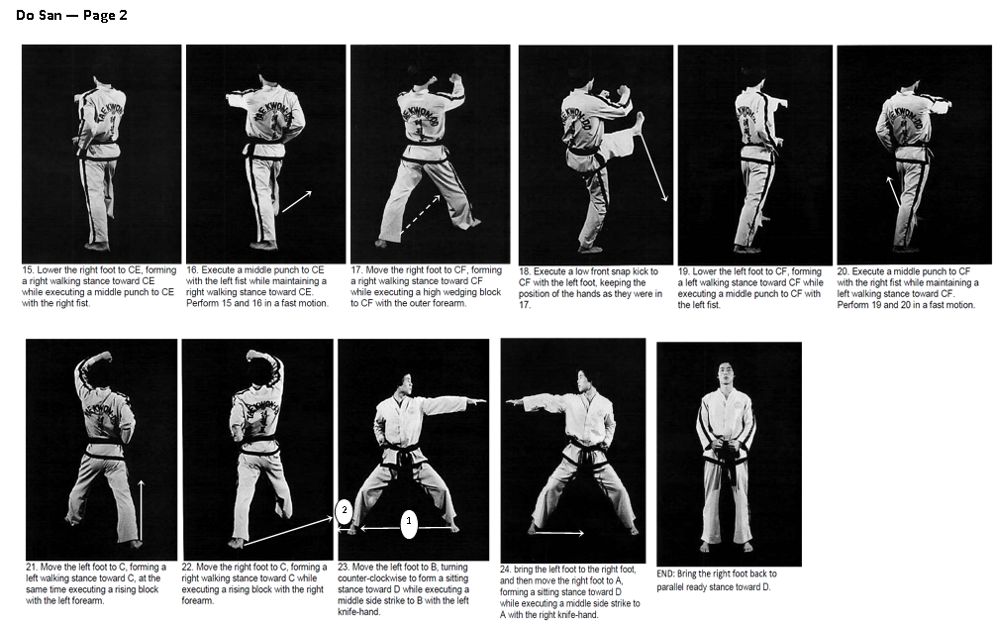
10
10
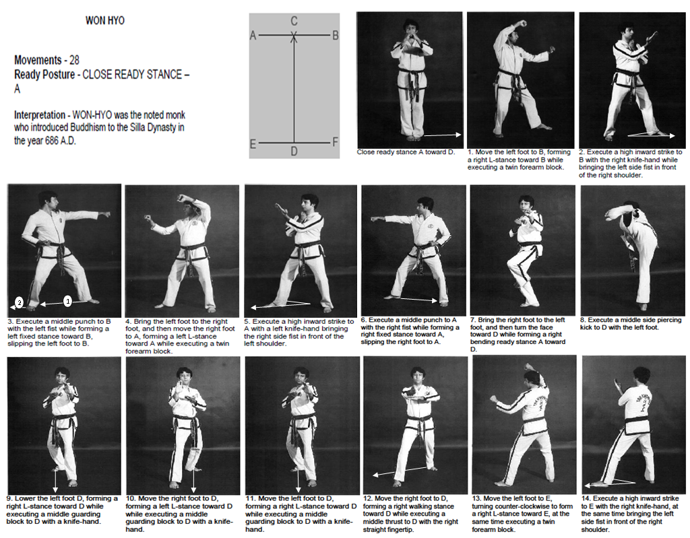
10
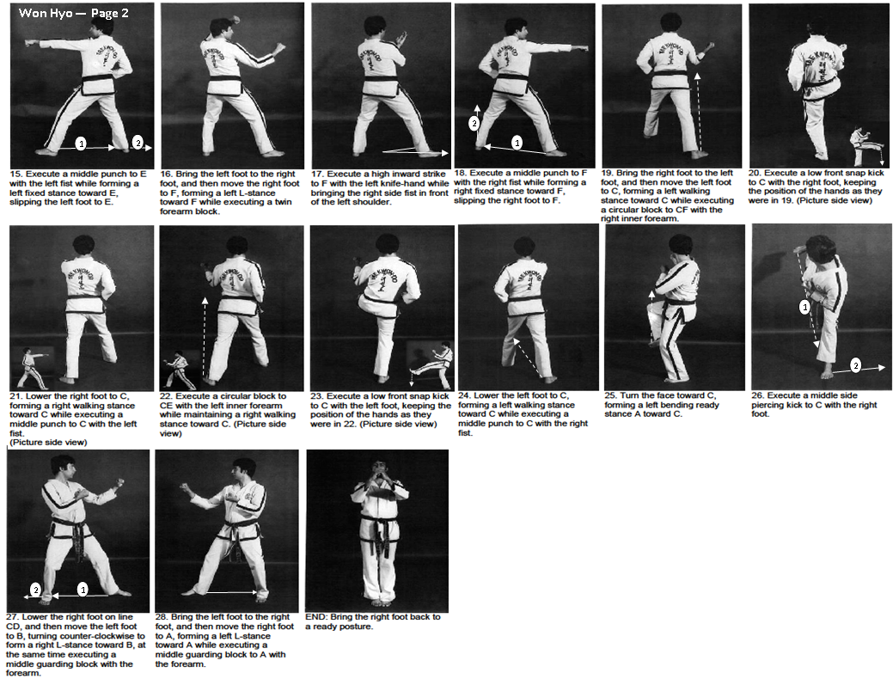
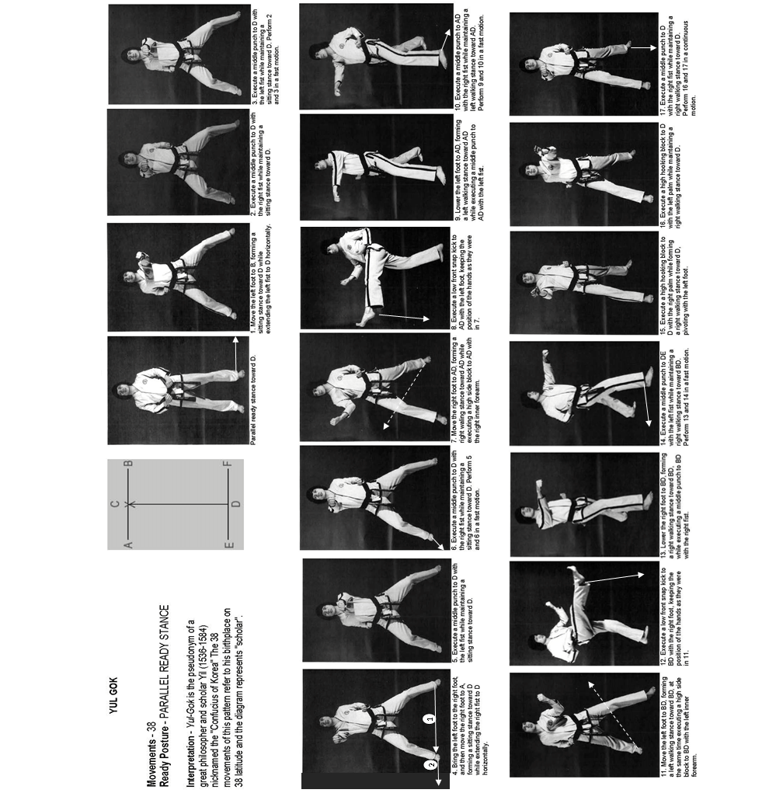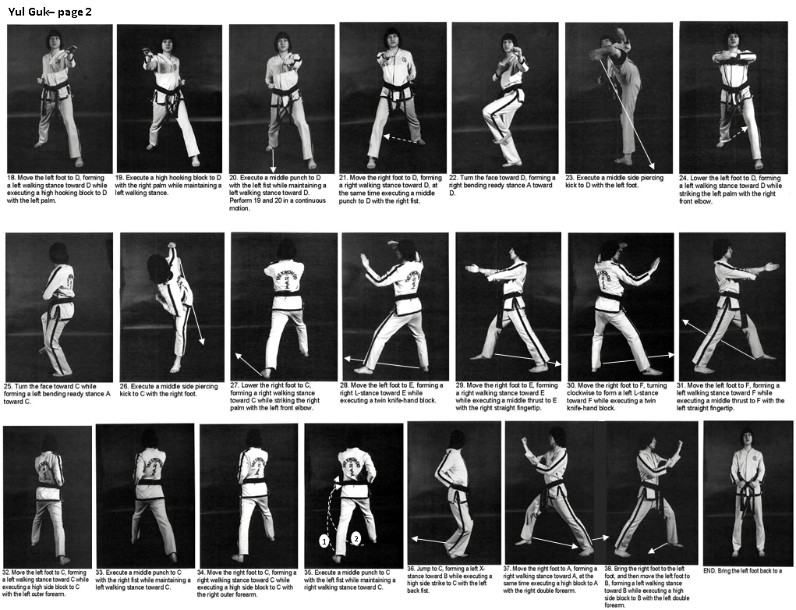

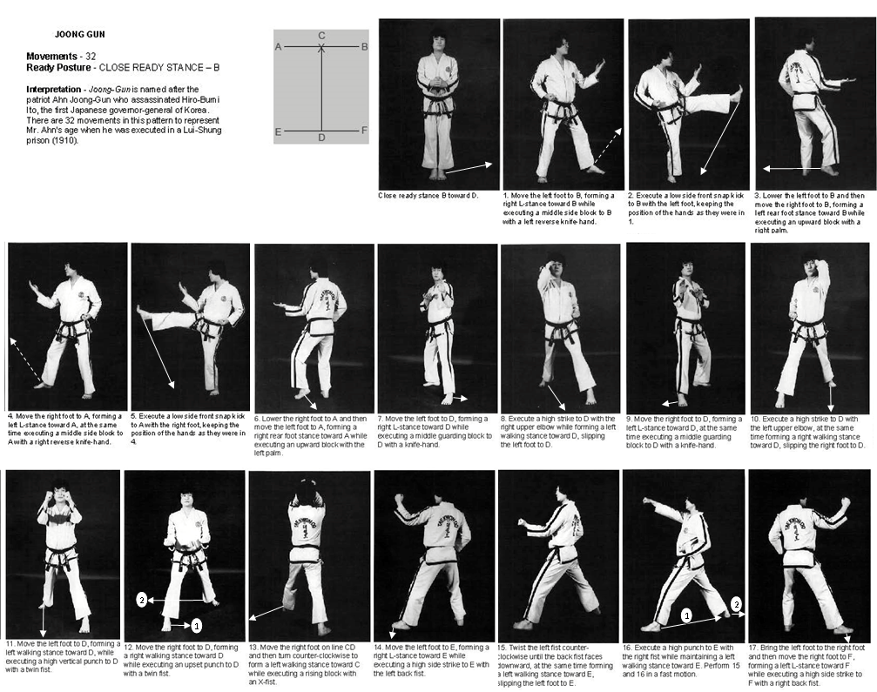
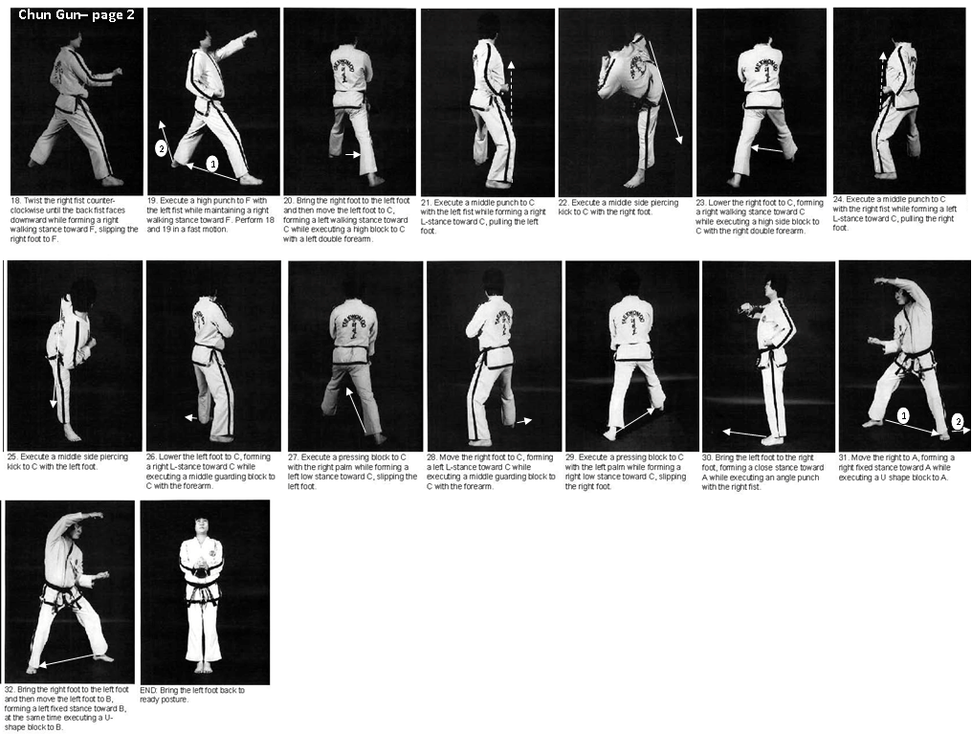
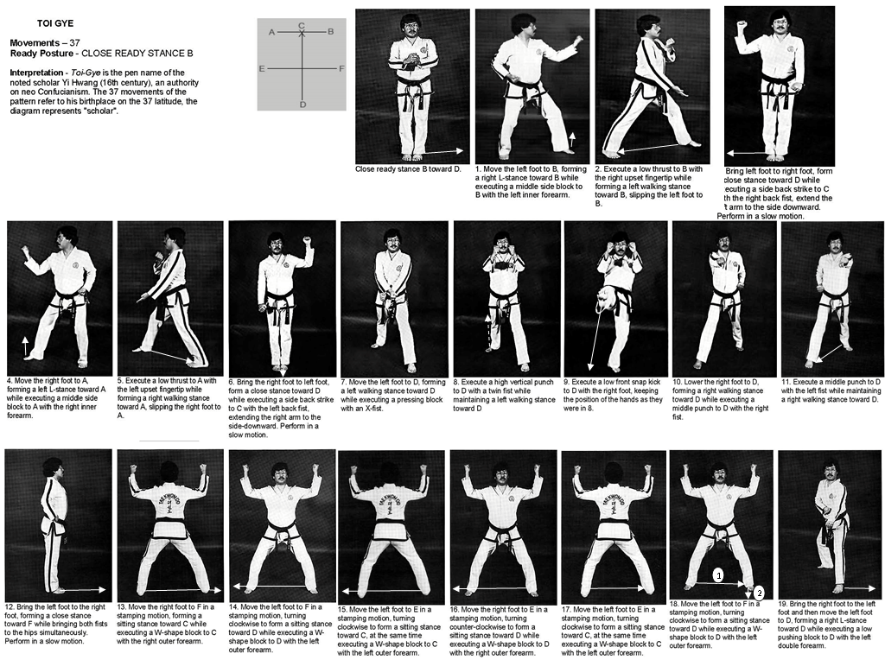
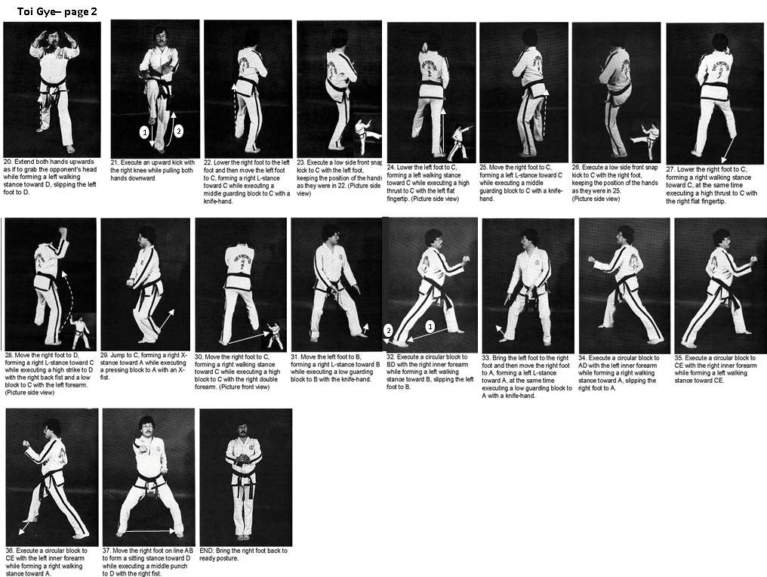
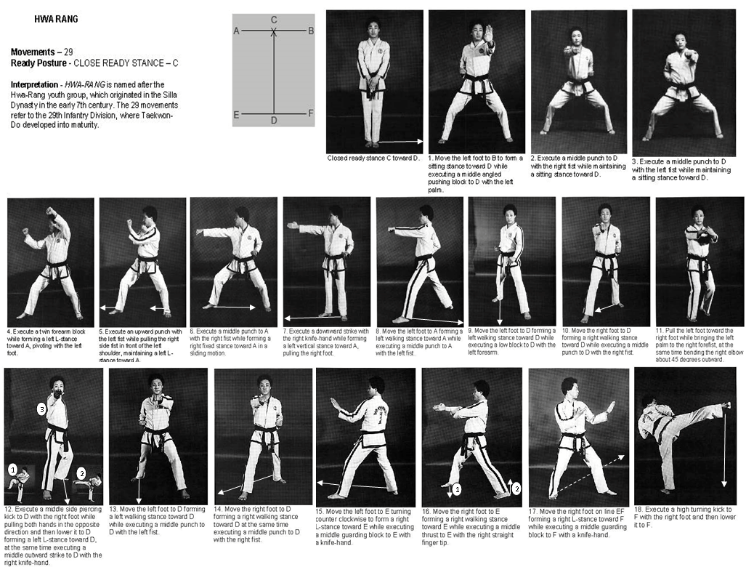
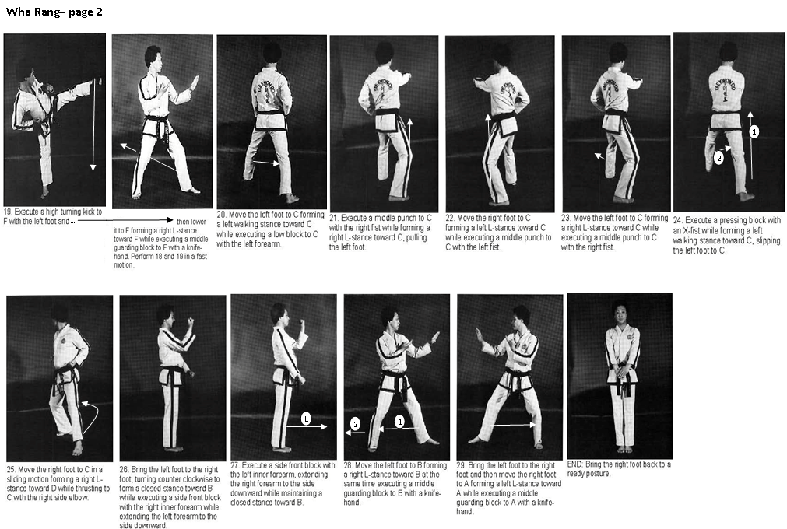
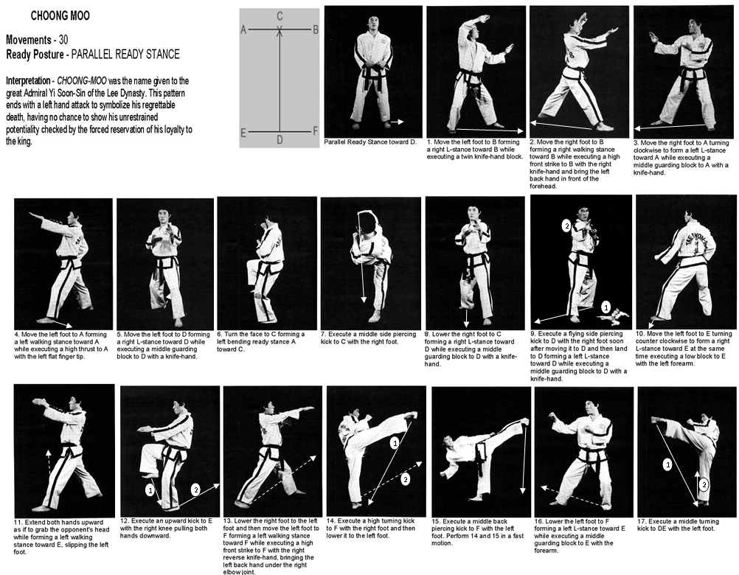
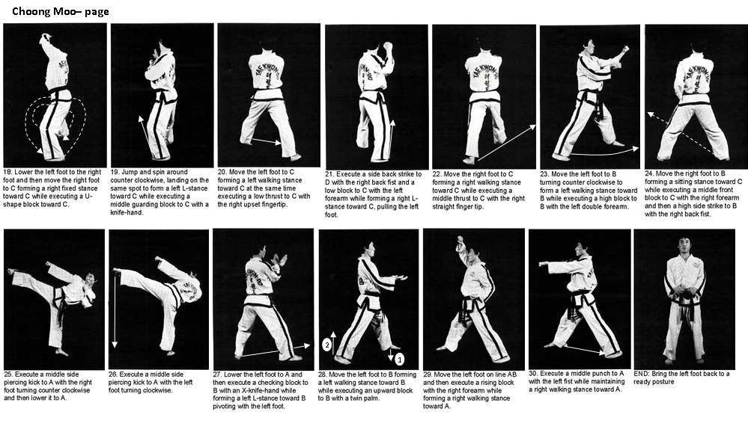

Advanced Curricula

Ho Sin Sul (Grab Defenses)

Defense to Wrist grabs
- A: Wrist grab across the body (Attacker grabs your right wrist with his right hands):
D: Step left with left foot as you simultaneously execute a clockwise circular hook block grabbing the attacker’s wrist. Execute a right-leg round kick to attackers’ mid-section. Follow with a right-leg downward crescent kick to attackers back followed by Kiop. Clear out to a guarding block, back stance. Practice with a left-hand wrist grab also.
- Attacker grabs both wrists from the front (Attacker grabs your right wrist with his left hand, your left wrist with his right hand): Step back into a front stance with either leg. Simultaneously perform a counter-clockwise circular release with your right hand and a clockwise circular release with your left hand. This will bring the attackers head down. Grab his shoulders and pull his head down as you execute a knee strike with the leg with which you stepped back. Kiop. Clear out to a guarding block, back stance.

Defense to Pushes
- A: Pushes with both hands
D: Slap down both arms and execute thumb gouge to eyes. Then a right elbow to jaw. Finish by pulling him into a knee strike. Push him away and front kick.
- A: Pushes with both hands
D: Slip sideways (pulling your right foot back as in an “ELITE” step) as you execute out to inside forearm block. Execute a ridge hand to neck. Finish with side kick to knee and ax kick to spine with the same leg.

Defense to Single arm lapel/shoulder grabs
- A: Right hand Lapel Grab from front (Same Side Grab).
D: Defender grabs the sleeve of attacker with right hand at his elbow and grabs with the left hand the middle of his back. He then pulls attacker backwards while sweeping his leg with his left foot to a takedown. Finishes with a punch or stomp.
- A: Grabs shoulder with 1 arm, same side grab
D: Slips head under attacker’s arm to the outside as he executes a ridge hand strike to neck as he steps behind attacker’s right leg preparing for a sweep. He then does Osoti-Geri Sweep. Finishes with a stomp kick.
- A: Grabs lapel with right hand
D: Wraps his left arm in a clockwise motion around attacker’s arm putting him in an elbow lock and bending him over backwards as he sweeps him with left foot. When attacker hits the ground, defender puts him in a straight arm elbow lock. (or you could simply finish with a stomp kick.)
- A: Grabs shoulder with 1 arm, same side grab
D: Wraps his left arm in a clockwise motion around attacker’s arm putting him in an elbow lock and
executes a right upset punch to body and right knee to body.
- A: Grabs shoulder with 1 arm, same side grab
D: Slips head under attacker’s arm to the outside as he spins to execute a left elbow strike and then
reverses his spin, sweeping the attackers leg with his right foot.
- A: Grabs shoulder with 1 arm, same side grab
D: turns and execute left knife hand strike and right ridge hand.
- A: Attacker grabs your lapel and tries to punch you with his other hand.
D: Block the punch with one hand as you trap his grab with your other hand. After blocking punch, execute a palm-up knife hand strike to the side of his neck. Reach across and grab the hand you trapped and place him in a wrist lock. Finish with a kick to the back of his knee. Kiop. Clear out to a guarding block, back stance.

Defense to 2-hand Lapel grabs
- A: Twin Lapel Grab and pulls defender in close to him.
D: Executes a twin palm punch to jaws and immediately follows with a jump front kick.
- A: Twin Lapel Grab pulling Defender in to him.
D: Defender places his left hand on the opposite side of attacker’s jaw and pushes attackers head to the
left as he executes a right cross to the jaw.
- A: Twin Lapel Grab
D: Defender snakes’ right arm over and under attacker’s forearms. Then with left hand grabbing his right fist, pushes up and over to right breaking hold. Defender counters with a right uppercut and then grabs the attacker’s shoulders to pull him into a right knee strike.
- A: 2 hand lapel grab.
D: Stepping back with right leg and, with left forearm, execute a downward block to attacker’s arms.
Follow with a right elbow or right cross to his jaw.
- A: Grabs lapels and attempts a head butt.
D: Blocks head butt with heaven hands, then grabs the attacker by the back of the head with left hand and executes a right horizontal elbow strike to jaw. (Alternate finish: He finishes by executing a right reverse throat choke as he strikes the attackers trunk with knee strikes.)
- A: Grabs throat with left hand, then punches with right fist to head
D: With left hand, execute inward palm block to throat grab and outward knife hand block to punch. Counter with right-left punches and finish with rear leg (R) Jump Front Kick.
- A: Grabs throat with both hands.
D: Executes right forearm Inward Block to break hold and continues to spin around to a left rear elbow strike. He finishes by reversing to the right and executes a right rear elbow attack.
- A: Twin Lapel Grab.
D: B: Executes right forearm Inward Block to break hold and counters with a left upset punch to body and right downward hook to jaw.
- A: Twin Lapel Grab
D: Answers with a right punch-left punch combo to throat and finishes with a jump front kick.
- A: Front choke with both hands:
D: Tuck your chin down so attacker can’t get a good hold on your neck. Grab both of the attacker’s wrists as you step back with your right leg. Execute a low front kick to attacker’s stomach. Let go his
wrists and raise your fists above your head. Execute a twin downward strike to his forearms with your hammer fists. Follow with a twin strike to his jaws with your palm heels. Kiop. Clear out to a guarding block, back stance.
- A: Attacker puts you in a Headlock from front (guillotine Choke).
D: Tuck your chin to your chest as soon as you can. Execute a ridge hand strike to his groin. Then with both hands, grab the arm around your neck and pull down hard, loosening his grip. Step through and behind him while putting him in and arm bar and forearm choke from behind. Take him down to the ground. Clear out to a guarding block, back stance.

Defense to Bear Hug
- Attacker grabs you from the front in a Bear Hug. Place both thumbs in the crease where his legs join his torso and push him away. At the same time step back with one of your legs and execute a knee strike to attackers’ stomach. Push him away and front kick. Kiop. Clear out to a guarding block, back stance.

Defense to Grabs from Behind
- A: One hand shoulder grab from behind (left hand)
D: Defender raises left arm high as he turns and executes a downward elbow to attackers’ arm,
breaking the hold. Immediately counters with a right cross to face.
- A: Twin wrist grab from rear
D1: Step away and Back Kick
D2: Step away with one leg, pulling attacker forward, then reverse your motion backwards so attacker
slams into your back, knocking the air out of him.
- A: Choke from Rear with hands.
D: Defender raises right arm high as he spins out clockwise (which breaks the hold). He continues to turn to face the attacker as he grabs attacker with both hands and pulls him into a right knee strike. He finishes with a downward elbow to the opponent’s spine.
- A: Rear arm bar choke with right arm
D: Steps out to right into a riding stance as he executes a left rear elbow strike to solar plexus. He then retorques his body to the left and executes a right “angle punch” over his left shoulder to opponent’s face.
- A: Attacker comes up from behind and puts you in a headlock from the side (he hugs your head with his right arm):
D: Tuck your chin and head in case he tries to punch you. If he does start punching reach across your body with your right hand and grab the arm he is punching with. With your left arm reach up behind his shoulder and between your head and his. Place your index and middle fingers under his nose and sharply pull his nose upwards and backwards in the shape of an upside-down j. Take him down backwards onto his back. Kiop. Clear out to a guarding block, back stance.
- A: Attacker grabs you from behind in a bear hug:
D: Soften him up with a head-butt to the bridge of his nose. Inhale deeply and immediately drop your weight into a low horse-riding stance and shoot both arms out straight in front of you. This will cause the attacker’s arms to slide up. Immediately execute an elbow strike with one arm to his ribs or face. Then turn and execute another elbow strike with the other arm to his ribs or face. Execute both elbow strikes as a continuous motion. Step away and finish with a side kick to his mid-section. Kiop. Clear out to a guarding block, back stance.
- A: Attacker puts you in a Forearm Choke from Behind.
D: As soon as you sense a choke from behind, tuck your chin to your chest so he cannot cut off your air supply. Grab his forearm with both hands and pull down as you back out of the hold and put him in a rear arm bar and forearm choke of your own. Take him down backwards by backing up and forcing him down to the ground. Clear out to a guarding block, back stance.
- A: Attacker puts you in an Arm Bar from behind and is holding your wrist with his other hand.
D: First you must escape the wrist grab by pulling your wrist away and into a palm up position. Then with your free arm, execute a spin elbow strike to his head. Step away to release from the arm bar. Grab his wrist and round kick or side kick to body. Kiop. Clear out to a guarding block, back stance.
- A: Attacker chokes you with both hands from behind.
D: Tuck chin as soon as you sense the grab. Raise on arm high up overhead as you spin in the direction of your raised arm. This will release the choke hold. Quickly either counterattack or create distance between you and the attacker. Clear out to a guarding block, back stance.
- A: Attacker grabs you from behind in a Twin wrist grab.
D: Try Smashing his instep with a heel stomp. Then with either foot, step back towards attacker quickly as you shoot both hands out in front of you twisting the palms up. If done properly this will not only break the hold but also knock the wind out of him. Finish with a back kick to his sternum. Kiop! Clear out to a guarding block, back stance.
- A: Attacker puts you in a Full Nelson.
D: Try not to let him bend you down by placing the backs of both hands firmly against your forehead and push backwards. Suddenly, drop your weight into a low riding stance as you explosively drop your elbows to your ribs. This should break the hold. Step away and back kick to his sternum. Kiop. Clear out to a guarding block, back stance.

Takedowns and Ground Defense:
- Takedown to a 2-hand grab/punch: O’soto Geri Leg Sweep: Grab attacker and pull him into you as you step behind him deep with outside leg. With inside leg sweep the back of his calf and take him down.

- Takedown to a front kick: sidestep and perform a circular trapping block to catch his leg. Step behind attackers supporting leg and push shoulder backwards while lifting trapped leg up simultaneously, causing him to fall backwards.

- Takedown to a round kick: As attacker kicks step away from the kick as you execute a universal cross arm block to trap his leg. Once leg is trapped, Step behind attackers supporting leg and push shoulder backwards while lifting trapped leg up simultaneously, causing him to fall backwards.

- Escape out of a mounted position: Trap arm and leg, bridge and roll in the direction of trapped arm and leg to mount position. Finish with strikes and stand up and clear out into a guarding stance.

- Escape out of a guard position (bottom): Shift hips so you can get one foot locked into attacker’s lower abdomen and push him away as you slide away get the other foot into his abdomen and push him away. Finish with a kick to his face. Stand up and clear out into a guarding stance.

Choke Applications
- Slip to left of punch while executing palm block with left hand. Continue to slip behind partner and slide right arm over punching arm and around the front of partner’s neck and grab your left bicep. Elbow should be in front of Adam’s apple. Apply choke very slowly. Stop when partner taps.

- Slip to left of punch while executing palm block with left hand. Continue to slip behind partner and slide right arm under punching arm and around the back of partner’s neck. Bring your left arm around the front of your partner’s neck and grab your right bicep. Elbow should be in front of Adam’s apple. Apply choke very slowly. Stop when partner taps.

- Slip to left of punch while executing palm block with left hand. Continue to slip behind partner and slide right arm under punching arm and around the front of partner’s neck. Grab your left bicep. Apply choke very slowly. Stop when partner taps.

- As opponent punches, stepping with left foot, slip inside and blocking punch with left knife-hand. At the same instant slide your right arm around your partner’s head putting him in a front headlock choke and grab your left bicep.

Weapons Defenses

Club Defense One-steps
- A: Vertical strike downward
D: step 45 deg.’s left with left foot into front stance and execute high block with right arm. Slide forearm down and grab his wrist with right hand as you grab the back of his shirt about kidney level with your left hand. Pull him into you, and execute 2 knee strikes to his midsection with right leg. With left leg, sweep him backwards and down. Kneel down as he falls and follow up with 2 punches and then disarm stick over your left leg by striking his elbow against your leg.

- A: Horizontal strike, right to left
D: Step towards attacker with right leg into back stance as you execute a twin Knife hand block. With your left hand, grab his wrist as you execute a right Knife hand strike to his ribs. Step through to the left still holding wrist and pull his arm straight to your left side (this will bend him down). Execute a round/front kick to his mid-section with right leg. Then sweep him with left leg, taking him to the ground on his back. Kneel down as he falls and follow up with 2 punches and then disarm stick over your left leg by striking his elbow against your leg.

- A: Vertical strike downward
D: slips 45 Deg.’s left in a horse stance while coming in from behind with your left hand and grabbing the back of the attackers hand as it travels past you. With right foot step under his arm and behind him, putting him in a rear arm bar with right hand; disarm the stick with your left hand and place the stick across his neck (trachea). with right hand, let go of wrist and place other end of stick in the crook of your right arm. Then place your right palm behind his head to apply submission.

- A: Vertical strike downward
D: Step straight in to attack with left leg as you execute a high X block. With left hand grab his wrist and clear the arm to the left as you strike his neck with a right arc hand. Then with left leg step deeper and execute right leg sweep to his front leg, taking him down backwards. Kneel down as he falls and follow up with 2 punches and then disarm stick over your left leg by striking his elbow against your leg.

- A: Vertical strike downward
D: step towards attacker with left foot into front stance and simultaneously execute high block with left arm and palm strike to nose. Grab his wrist with left hand as you reach underneath his arm with your right hand and grab stick to disarm. Finish with strike with stick.

- A: Vertical strike downward
D: Step toward attacker with left leg and execute a stabbing block with left arm and punch to throat with right fist (simultaneously done). Trap

Short Stick Defense

  - Vertical Stick Defense 1: Parry outside to arm bar from behind, disarm stick and choke.
  - Vertical Stick Defense 2: Parry inside and reverse motion wrist lock.
  - Vertical Stick Defense 3: Reverse High Block (step 45 to left with left leg and high block with right arm). Grab attacker’s shirt at kidney level and pull into several right knee strikes to ribs. Then sweep backwards with left leg and once he’s down, transfer his attacking arm to your left hand and put in arm bar over left leg. Disarm.
  - Vertical Stick Defense 4: High X-Block, clear arm with left hand as you execute arc-hand to throat with right hand. Then sweep (Osoto-Geri), grab arm and arm lock.
  - Diagonal Stick Defense 1: High block, Reverse Punch, Grab and knee strike, elbow to spine.
  - Diagonal Stick defense 2: Stabbing Block. Trap arm. Elbow and knee strikes.
  - Horizontal stick defense 1: Universal cross arm block. Trap arm. Elbow and knee strikes then take down.
  - Horizontal stick defense 2: avoid 1st swing. Close and trap arm on return swing. Finish with leg sweep and arm bar.
  - Horizontal stick defense 3: Twin Forearm Block. Grab arm with left hand and strike with knife hand to ribs. Grab stick arm with both hands and circle under and turn and Round kick to stomach/face. Sweep backwards and put in arm bar.
  - Horizontal stick defense 4: Twin Forearm Block. Grab arm with left hand and strike with knife hand to ribs. Grab stick arm with both hands and circle under and turn and execute an arch kick to back of knee. Hammer fist to spine.

Knife and Gun Defenses are extremely dangerous, even life-threatening. As such, predicaments that place you in such situations should be avoided at all costs! If there is any way possible…flee the situation as quickly as you can. Running and yelling “FIRE!” repeatedly will draw attention which may stop the attacker for fear of being seen. In any case, your LAST RESORT should be to stay and defend yourself! There are strategies to help you escape such situations, but they are beyond the scope of this handbook.

Knife Defense
- To Overhead Downward Stab (angle 1)
- To Lunging Thrust (angle 8)
- To Horizontal Slashing (angle 4):
- To Horizontal Slashing (angle 5):
- To Diagonal Slashing (Downward angle 2 ):
- To Diagonal Slashing (Downward angle 3):
- To Diagonal Slashing (Upward angle 6):
- To Diagonal Slashing (Upward angle 7)
- To Upward Thrust (angle 9):
- To Threat Behind the back:
- To Threat Against the throat:

Handgun Disarms:
- Pointed at head
- Pointed at body
- Pointed at head from behind
- Pointed at body from behind
- 2 hand grip points at head
- 2 hand grip pointed at body
- Gangster grip at head
- Horizontal slapping disarm
- Vertical slapping disarm

